Activity 1 – Linking structure and function

Using the diagram of leaf cells write five sentences to describe how each type of cell is adapted to its function. Your sentences should have both a structure and a function linked together.
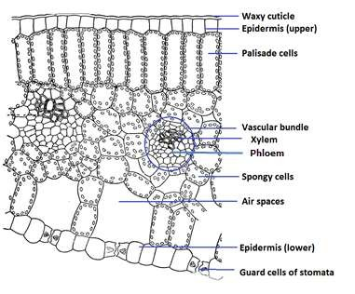
The functions should include:
The Cells of a Leaf

- absorption of light,
- production of glucose through photosynthesis
- gas exchange, of CO2 from the air to the leaf cells
- water conservation,
i.e. prevention of water loss
- the transport of water into the leaf (the transpiration stream)
- transport of products of photosynthesis out of the leaf.

For example:
The waxy cuticle of the leaf helps water conservation, it prevents water loss in the upper epidermis
………………………………………………………………….………………………………………………………………….
………………………………………………………………………….……………………………………………………..….
………………………………………………………………………………….…………………………………………..…….
………………………………………………………………………………………….………………………………..………
………………………………………………………………………………………………….………………………..……….
………………………………………………………………………………………………………….………………..……….
………………………………………………………………………………………………………………….………..……….
…………………………………………………………………………………………………………………………………….
.

Activity 2 – The Guard cell’s dilemma

This diagram shows the movement of water through a leaf from the xylem to the stomata. Use these details to answer the questions below.
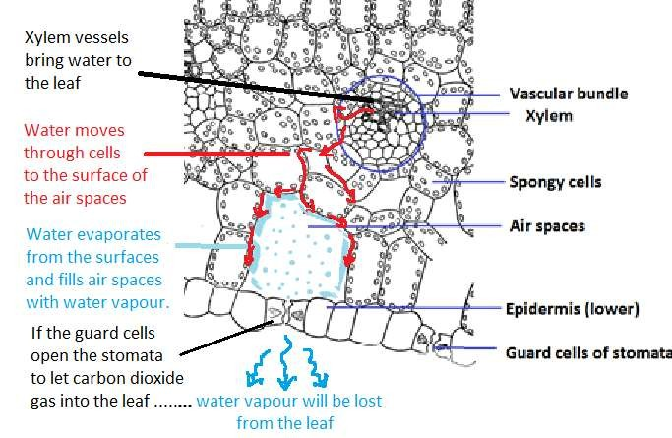

Questions
- Which gas is needed by the leaf so that it can do photosynthesis?
………………………………………………………………………………………………………………….
- How does this gas get into the leaf?
………………………………………………………………………………………………………………….
- When a leaf is fully hydrated the guard cells open the stomata. Which gases will diffuse into or out of the leaf.
………………………………………………………………………………………………………………….…
……………………………………………………………………………………………………………………..
- If the leaf is lacking water the guard cells close. What is the effect of this on the rate of photosynthesis.?
………………………………………………………………………………………………………………….
………………………………………………………………………………………………………………….

