**Translocation in the Phloem**

1. 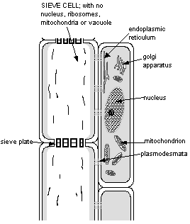**Phloem transport requires specialized, living cells**
   1. Cells called “______________________________” join to form a continuous tube
      1. lack some structures and organelles - no nuclei, vacuole, Golgi, ribosomes, or microtubules
      2. __________ in ___________________ between sieve tube elements are open channels for transport
   2. Each sieve tube element is associated with one or more *______________________________*.
      1. Transport products of photosynthesis from cells in leaves to sieve tube elements through ____________________
      2. Synthesize the various ________________ used in the phloem
      3. Contain many, many __________________ for ____________________________ to provide the cellular energy required for active transport
2. **What is transported in phloem?**
   1. The phloem is the vascular system for moving (_________________________) ________________ produced in photosynthesis and other substances throughout the plant.
   2. Carbohydrates transported in phloem are all *_________________________* sugars.
      1. Reducing sugars, such as *____________* are too chemically reactive to be transported in the phloem
      2. 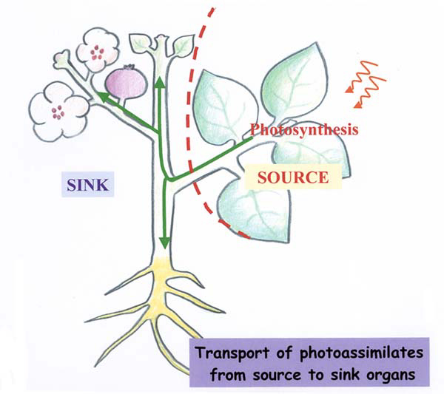The most common transported sugar is *_________* , a disaccharide m*ade up from glucose & fructose*
3. **The mechanism of phloem transport -** the _____________________________
   1. Phloem transports sugars from a “____________” to a “____________”
      1. *___________*: Any exporting region that produces sugars above and beyond that of its own needs
      2. *___________*: Any area that does not produce enough sugar to meets its own needs.
   2. In ***source tissue***…
      1. Sugars are moved from photosynthetic cells and actively loaded (uses ATP energy) into companion cells and sieve tube elements.
      2. Phloem loading uses a _______________________________________________.
      3. Phloem loading leads to a buildup of sugars (the phloem cells become _______________)
      4. In response, _______________ enters sieve elements from xylem via _________________
      5. *Thus phloem __________________ increases*
   3. In ***sink tissue***…
      1. Phloem unloading leads to lower sugar concentration (the phloem cells become __________________)
      2. ____________ leaves the phloem and enters sink sieve elements and xylem (via _________)
      3. *Thus phloem _________________ decreases*
   4. 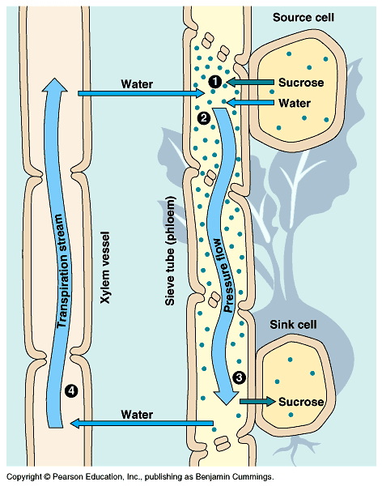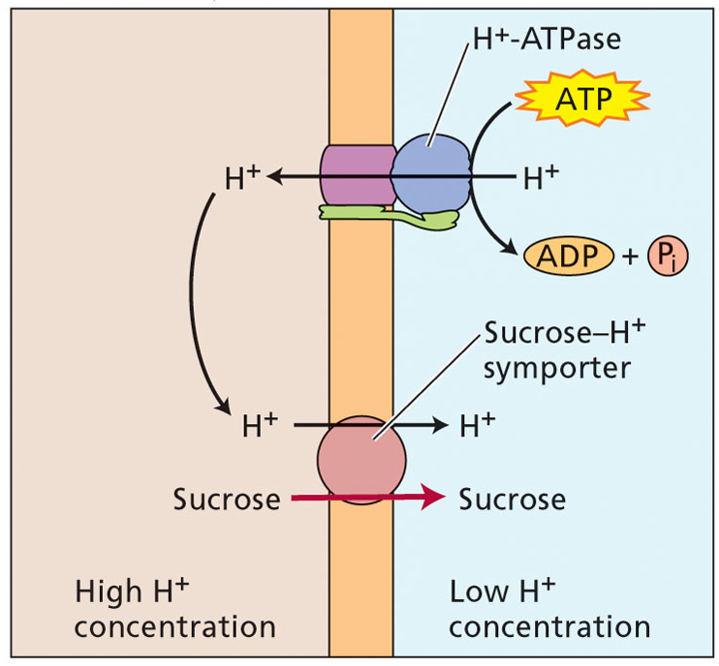Phloem solution moves along a ___________________ ______________ generated by a solute concentration difference between source and sink ends of the pathway.