Muscle contraction

Activity 1- Muscle structure

Below is a diagram of the ultrastructure of a muscle fibre.

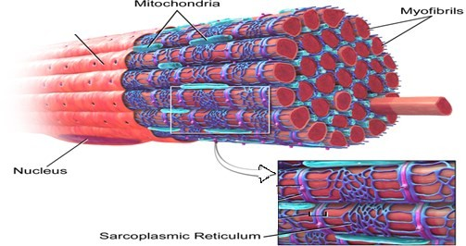“Skeletal Muscle" by Bruce Blaus. Wikiversity Journal of Medicine. - CC BY 3.0 via Wikimedia Commons - http://commons.wikimedia.org/wiki/File:Blausen_0801_SkeletalMuscle.png#mediaviewer/File:Blausen_0801_SkeletalMuscle.png

Describe and explain the functions of each of the four parts of the muscle fibre shown in the diagram above.

………………………………………………………………………………………………………………………………………………

………………………………………………………………………………………………………………………………………………

………………………………………………………………………………………………………………………………………………

……………………………………………………………………………………………………………………………………………….

……………………………………………………………………………………………………………………………………………….

……………………………………………………………………………………………………………………………………………….

………………………………………………………………………………………………………………………………………………

………………………………………………………………………………………………………………………………………………

………………………………………………………………………………………………………………………………………………

Activity 2 – Sarcomeres and muscle contractions

The diagram below shows a sarcomere.

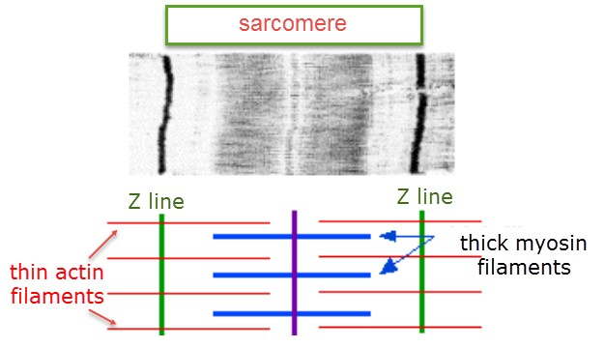

1. Label the light and dark bands on the diagram.

2. Explain why the bands look light, or dark on an electron microscope image.

………………………………………………………………………………………………………………………………………………………..

………………………………………………………………………………………………………………………………………………………..

………………………………………………………………………………………………………………………………………………………..

………………………………………………………………………………………………………………………………………………………..

This diagram shows a sarcomere in another muscle myofibril.

3. Distinguish between the two electron microscope images.

………………………………………………………………………………………………………………………………………………………..

………………………………………………………………………………………………………………………………………………………..

