Phloem – translocation experiments

Activity 1 – Experiment using radioactive 14C

Radioactive isotopes can be used track the movement of sucrose by translocation in the phloem. The radioactivity can be traced using photographic film (an autoradiograph).

In a typical experiment like those carried out by Bidulph and Cory at Washington State University in the 1960s a plant is grown in the lab and one leaf is exposed for a short time to carbon dioxide containing the radioactive isotope 14C.

The diagram shows three experiments where different leaves were exposed to 14CO2 for 3 hours. Images A2, B2 and C2 show the autoradiographs which locate radioactivity six hours after exposure.
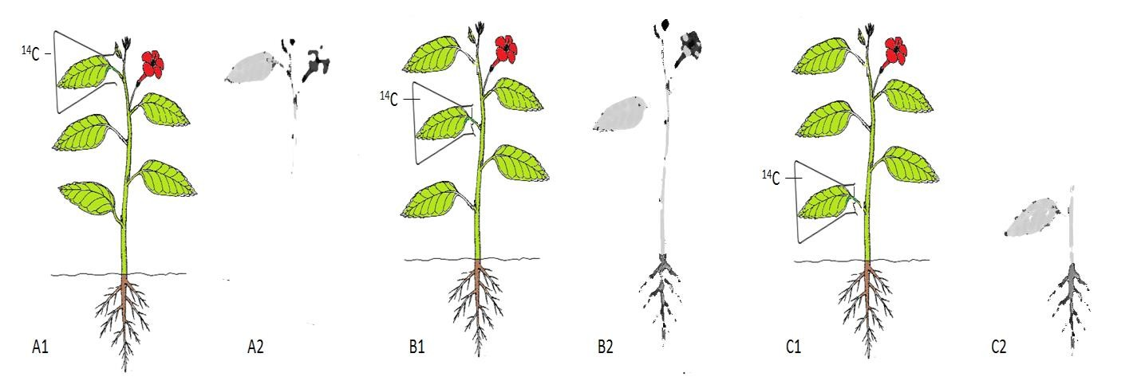

Questions
- Describe what would happen to the 14CO2 within the leaf in each experiment, before any translocation occurs.
………………………………………………………………………………………………………………………………………….
………………………………………………………………………………………………………………………………………….
………………………………………………………………………………………………………………………………………….

- After six hours, the plants were frozen in liquid nitrogen, before being put onto photographic film to make the autoradiograph. Suggest why the plant must be frozen quickly.
………………………………………………………………………………………………………………………………………….
………………………………………………………………………………………………………………………………………….
………………………………………………………………………………………………………………………………………….

- Each leaf is described as a “source” because it provides sucrose for other “sink” areas of the plant. Describe the translocation of sucrose containing 14C in each of the three experiments A, B and C
………………………………………………………………………………………………………………………………………….
………………………………………………………………………………………………………………………………………….
………………………………………………………………………………………………………………………………………….

Activity 2- Aphid stylet experiment

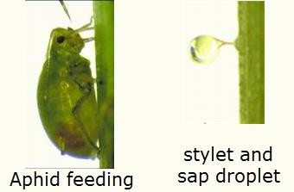
In the 1960’s, M.J. Canny of Cambridge university carried out some experiments using the stylets of aphids to collect samples of phloem sap containing radioactive sucrose in the bark of willow trees.

Aphid stylets are used to feed on the sap of phloem tubes. If the aphids are anaesthetized the stylets can be cut off. The stylet stays in the phloem and phloem sap can be collected through the stylet for analysis

Aphids were positioned on the willow cutting at different distances downwards from the leaf treated with 14C. The graph shows the results five hours after the treatment.

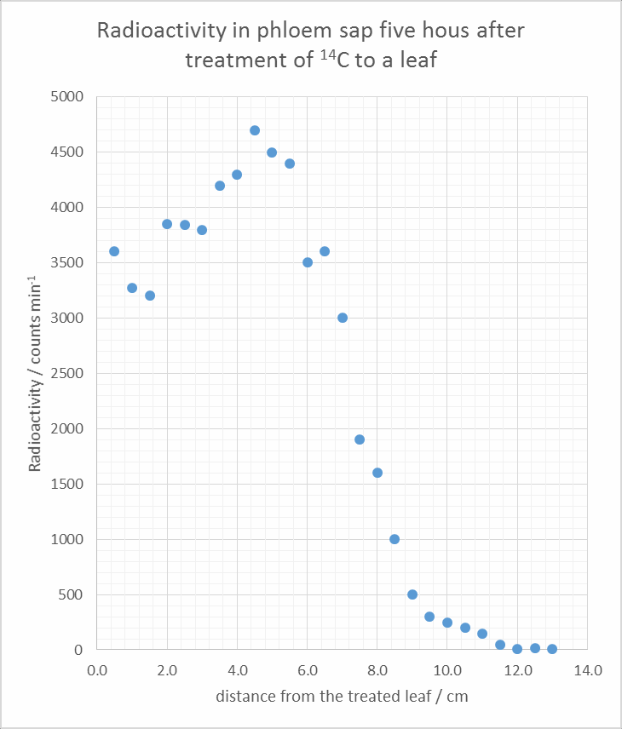
Questions

  - At what distance from the treated leaf is there the most radioactive phloem sap?
…………………………………………………………………………
……………………………………………………………………….

  - Identify the furthest distance that radioactive sap has travelled from the leaf
……………………………………………………………………
…………………………………………………………………….

  - Calculate the maximum rate of movement of phloem sap in this experiment. (show your working)
……………………………………………………………………
…………………………………………………………………….
……………………………………………………………………
…………………………………………………………………….
…………………………………………………………………… ……………………………………………………………………

  - Suggest why the all radioactivity does not travel down the phloem at the same time.
………………………………………………………………………………………………………………………………………….
………………………………………………………………………………………………………………………………………….
………………………………………………………………………………………………………………………………………….
………………………………………………………………………………………………………………………………………….

Answers

1. This 14CO2 will be taken up by photosynthesis and the 14C incorporated into glucose and then sucrose
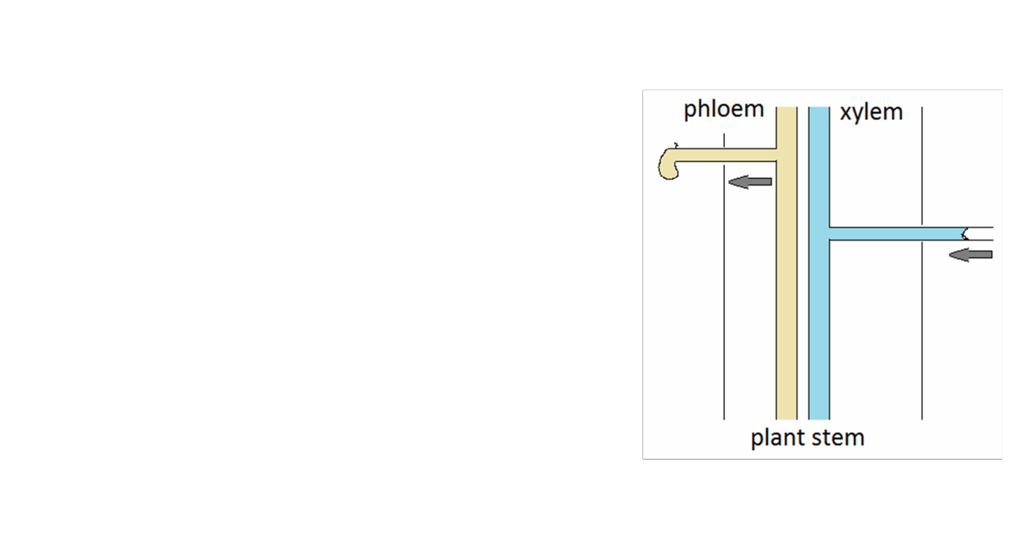
Interesting note
Phloem punctured with a hollow tube oozes sap,
showing that there is high pressure inside the phloem. This is evidence to show that sap is “pushed” down the phloem from source to sink.

If the xylem is punctured then air is sucked in, showing that there is low pressure inside the xylem. This is
evidence that tension “pulls” water up the xylem.

