Muscle Contraction

Activity 3 – Sliding filament theory

- Write descriptions of what is happening in each of the four steps in the table below. This will produce a summary diagram showing how the muscle contracts by the sliding of the filaments. (Use the statements overleaf

 | Images of four steps |  |  |  | Description of what happens.
 |  |  |  |  | ………………………………………………………………..
 |  |  |  |  | ……………………………………………………………….
 |  |  |  |  | ………………………………………………………………..
 |  |  |  |  | ……………………………………………………………….
 |  |  |  |  | ………………………………………………………………..
 |  |  |  |  | ……………………………………………………………….
 |  |  |  |  | ………………………………………………………………..
 |  |  |  |  | ……………………………………………………………….
 |  |  |  |  | ………………………………………………………………..
 |  |  |  |  | ……………………………………………………………….
 |  |  |  |  | ………………………………………………………………..
 |  |  |  |  | ……………………………………………………………….
 |  |  |  |  | ………………………………………………………………..
 |  |  |  |  | ……………………………………………………………….
 |  |  |  |  | ………………………………………………………………..
 |  |  |  |  | ……………………………………………………………….
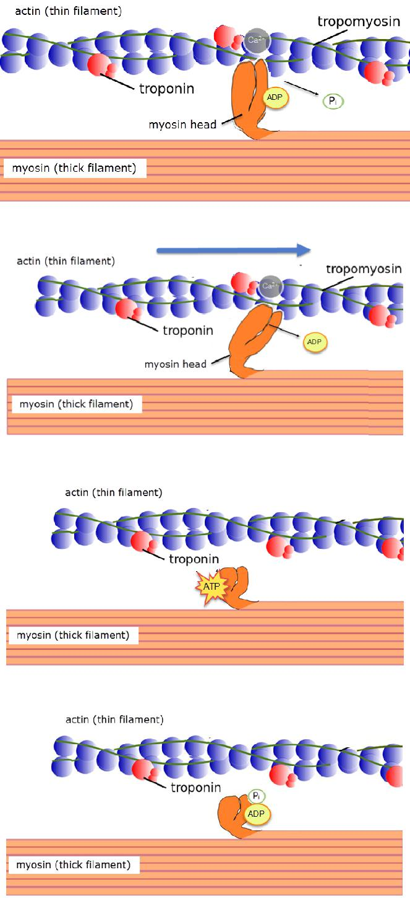

Choose from the phrases below to complete the table above.

- When a nerve impulse arrives Ca²⁺ ions are released.

  - Ca²⁺ ions bind with troponin, causing it to change shape which exposes the myosin binding site.

  - A cross-bridge is formed between actin and myosin.

  - Pi is released and the myosin head is bound to actin.

- Energy in the head of the myosin myofilament

  - moves the head, which

  - slides the actin past.

  - ADP is released.

- The myosin heads

  - disconnect from the actin to

  - grab more ATP.

- The ATP is then broken down

  - into ADP and Pi

  - The energy released is stored in the myosin head.

