Micropropagation – definition and uses

Activity 1- What is a plant meristem?

A meristem is an area containing undifferentiated cells which divide by mitosis throughout the life of the plant. The elongation and subsequent specialisation of these cells are controlled by expression of genes in the cells themselves and in response to plant hormones, like auxin.
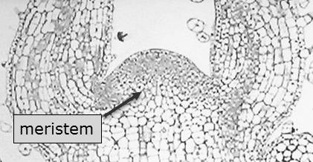

Explain each of these aspects of a plant meristem

Aspect of meristems | Explanation
Undifferentiated cells
Doing mitosis continually
Controlled by hormones
Elongate and differentiate

Activity 2- What is micropropagation and where is it used?
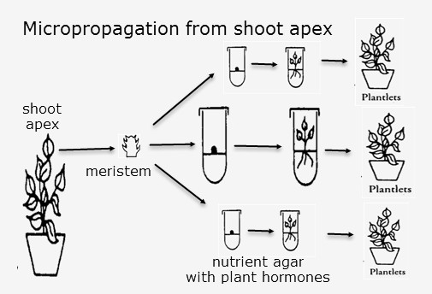
Micropropagation can be carried out by cutting the meristem from the shoot apex of a plant and growing the cells in nutrient agar. The agar must be sterile, and it needs to contain plant hormones. The small plantlets which grow can be planted in soil and eventually grow to full-size plants.

Use the web links in the support material on Weebly to complete
Source | Definition of micropropagation?
San Diego Zoo, USA | It is invitro regeneration of plant material. A way to grow plants that are normally difficult to grow from seeds or cuttings.  It is an essential tool in plant conservation, supplying large quantities of plants for reintroduction projects and fieldwork
North Carolina University USA.
Makerere University, Uganda
Kew Gardens, London

Write a generalised definition of micropropagation in the space below Micropropagation is …

Activity 3 – What are the benefits of micropropagation?
Use the web links to find uses and benefits of micropropagation:

Which organisation? | What do they do with it? | What are the benefits?
San Diego Zoo, USA | They grow orchids, bamboo, cycads, and coral trees. | To facilitate trade between institutions.  To reduce the number of rare plants taken from the wild
North Carolina University USA.
Makerere University, Uganda
Kew Gardens, London

Risks or Dangers of micropropagation

