Practicing DNA Transcription and Translation

For the following examples, give the appropriate sequence of DNA, mRNA, tRNA and/or polypeptide (AA = amino acids). Remember: A codon chart can only be used for decoding a strand of mRNA.
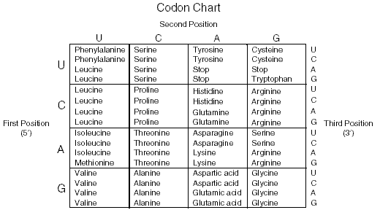

Example 1:
DNA: | T A C | G C G | C C T | A G G | G G G | T G G
mRNA: | _ |  |  |  |  | _ _
AA: | _ | _ |  |  |  | _
Example 2: DNA: | T T C | G A T | T A G | A T G | C C G | A A G
mRNA: | _ |  |  |  |  | _ _
tRNA: | _ | _ |  |  |  | _
AA: | _ | _ |  |  |  | _
Example 3:
DNA: | C _ _ | _ G _ | A _ _ | _ A _ | _ _ C | _ T _
mRNA: | _ U _ | _ _ A | _ _ C | _ _ A | _ G _ | _ A _
tRNA: | _ A U | G _ U | _ U G | G _ U | C C _ | G _ A
AA: | _ | _ |  |  | _

Protein Synthesis Overview Diagram

Label the summary of protein synthesis diagrammed below using the following terms: transcription, translation, DNA, mRNA, ribosome, tRNA, amino acid, polypeptide, nucleus, codon, and anticodon.

