Seeds, flowering and phytochromes

Seeds are a crucial part of plant reproduction and there are many methods used by plants for seed dispersal. This activity covers both seed structure and dispersal. Flowering in any plants takes place at specific times of the year. The timing of flowering is controlled by phytochromes (P_{r} & P_{fr}) which enable plants to detect day length and control gene expression.

Q1

Diagram of a dicotyledonous plants

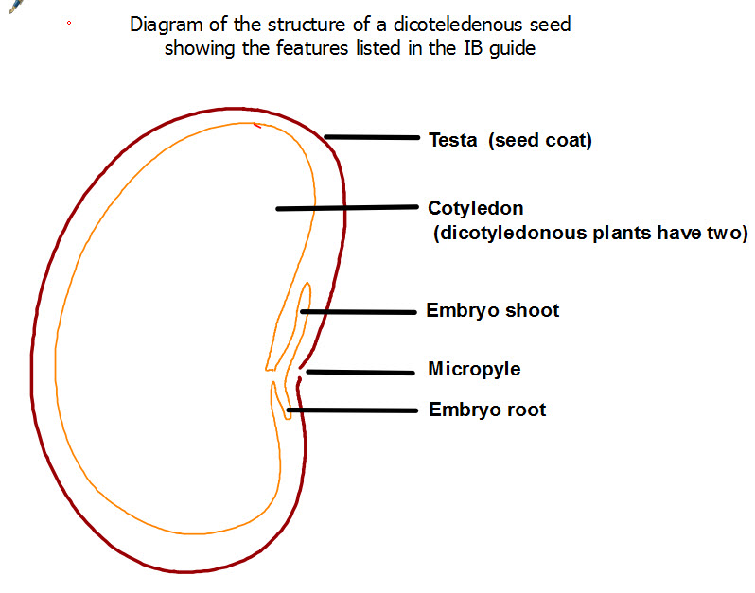
[Grab your reader’s attention with a great quote from the document or use this space to emphasize a key point. To place this text box anywhere on the page, just drag it.]

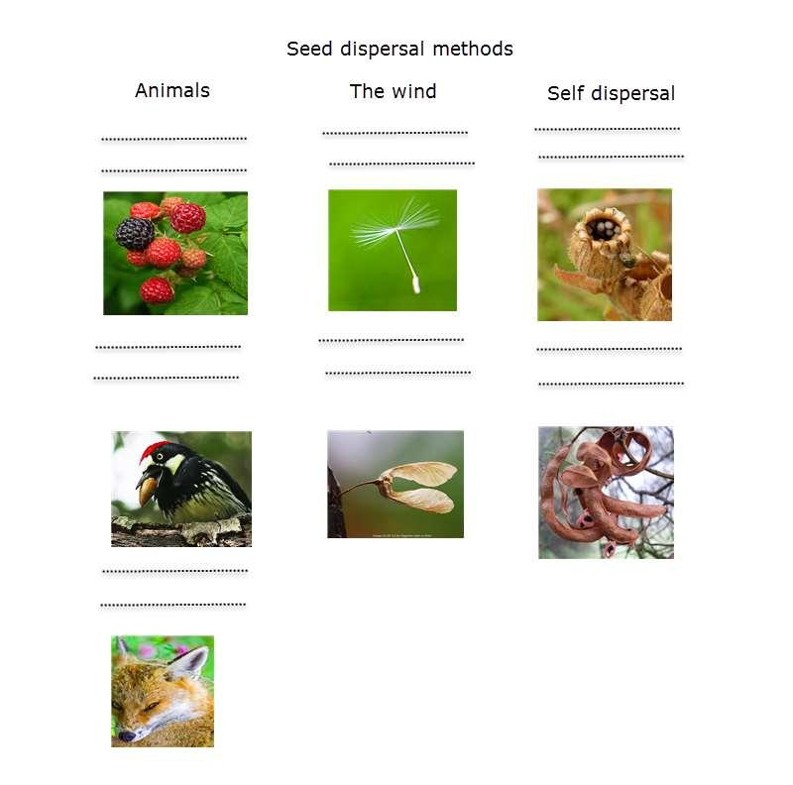
Describe how the seeds in the images below are dispersed
Question

Q2.Compare and contrast the role of animals in seed dispersal and pollination

…………………………………………………………………………………………………………………………………

…………………………………………………………………………………………………………………………………

…………………………………………………………………………………………………………………………………

Control of flowering
Plants can absorb light and respond to it using special pigments. We know already that guard cells open stomata in the presence of light. Seeds germinate in response to light, and flowers flower at specific times of the year controlled by the amount of light in a day (daylength)a few ideas about germination.

Key points about phytochrome
- The pigment phytochrome exists in two inter-convertible forms.
- One form of phytochrome, named P_{fr}, is found in plant cells that are exposed to red light (660 nm) or daylight.
- This form of phytochrome P_{fr} is biologically very active
- Pfr promotes flowering in many plants.
- The other form of phytochrome, named P_{r}, is formed when phytochrome is exposed to far-red (730 nm) light.
- This form P_{r} is biologically inactive or inhibits responses.

This diagram summarises the role of phytochrome in the initiation of flowering.
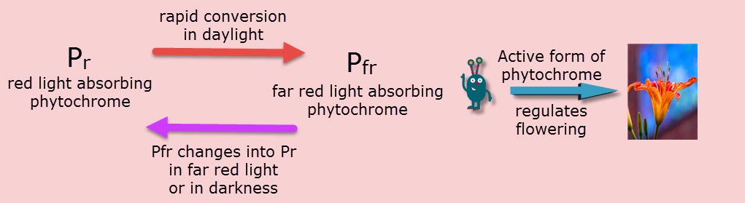
Q3. Explain how day length can stimulate the production of flowers.
……;.…………………………………………………………………………………………………………………………………………………………………………………………………………………………………………………………………………………………………………………………………………………………………………………………………………………………………………………………………………………………………………………………………………………………………………………………………………………………………………………………………………………………………………………………………………………………………………………………………………….……………………………………………………………………………………………………………………………………………………………………………………………………………………………………………………………………………………………………………………………………………………………………………………………………………………………………………………………………………………….…………………………………………………………………………………………………………………………………………………………

