Xylem and Phloem – animation analysis activity

This activity uses the excellent animation produced by SAPS - http://youtu.be/LQ03xIkLLQU
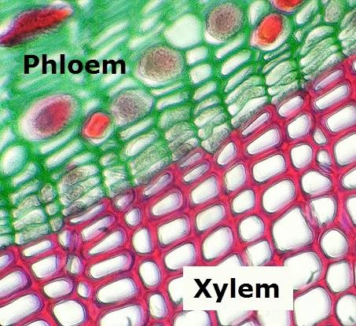

Figure 1 Phloem Xylem and the cambium meristem - adapted from Fickleandfreckled CC on Flickr

Activity 1- The xylem and phloem in roots
Use the vertical section through a root (low power is best)

- Which direction do the blue water molecules travel in the xylem
…………………………………………………………………………………………………………………………………………….
…………………………………………………………………………………………………………………………………………….
- Which way to the red sugar molecules travel?
…………………………………………………………………………………………………………………………………………….
…………………………………………………………………………………………………………………………………………….
- Which vessels are biggest the red xylem or the yellow phloem?
…………………………………………………………………………………………………………………………………………….
…………………………………………………………………………………………………………………………………………….

Activity 2 – The xylem and phloem in a stem
Use the vertical section through a root (high power is best)

- Which way do the blue water molecules travel to get into the xylem? Do they go through cell cytoplasm or cell walls, or both?
…………………………………………………………………………………………………………………………………………….
…………………………………………………………………………………………………………………………………………….
- Which way to the red sugar molecules travel?
…………………………………………………………………………………………………………………………………………….
…………………………………………………………………………………………………………………………………………….
- Why do some red sugar molecules disappear in the blue parenchyma cells?
…………………………………………………………………………………………………………………………………………….
…………………………………………………………………………………………………………………………………………….

Activity 3 – The xylem and phloem in a leaf

Use the vertical section through a leaf

- Where do the red sugar molecules appear first? Explain why?
…………………………………………………………………………………………………………………………………………….
…………………………………………………………………………………………………………………………………………….
- Do you ever see red sugar molecules in the red xylem tubes? Explain your answer.
…………………………………………………………………………………………………………………………………………….
…………………………………………………………………………………………………………………………………………….
- How do most water molecules leave the leaf?
…………………………………………………………………………………………………………………………………………….
…………………………………………………………………………………………………………………………………………….

