Angiosperm Reproduction

Essential Idea(s):
Reproduction in flowering plants is influenced by the biotic and abiotic environments.

IB Assessment Statements and Class Objectives
9.4.S2: Drawing of half-views of animal-pollinated flowers.
- Draw and label an animal pollinated flower, including:

  - Nectar-secreting glands
  - Petals
  - Sepals
  - Stamen
  - Anthers
  - Filaments
  - Pistil
  - Stigma
  - Style
  - Ovary
  - Ovule

- State the function of the different parts of the animal-pollinated flower.

9.4.U1: Flowering involves a change in gene expression in the shoot apex.
- List the vegetative and reproductive structures of an angiospermatophyta.
- State that flowers are produced from a shoot apical meristem.
- State two abiotic factors that may trigger flowering.
- Compare the timing of flowering in short-day plants and long-day plants.
- Outline the process by which changes in gene expression trigger flowering.

9.4.U2: The switch to flowering is a response to the length of light and dark periods in many plants.
- State the role of the pigment phytochrome.
- Describe the conversions between the two forms of phytochrome.
- Describe role of phytochrome in controlling flowering in long and short day plants.

9.4.A1: Methods used to induce short-day plants to flower out of season.
- State how plants can be manipulated to force flowering out of season.

9.4.U3: Success in plant reproduction depends on pollination, fertilization and seed dispersal.
- Define pollination, fertilization and seed dispersal.
- State the changes to the ovule and ovary that result from fertilization.
- List mechanisms of seed dispersal.

9.4.S1: Drawing internal structure of seeds
- Draw and label the structure of seeds, including:

  - Embryo root
  - Embryo shoot
  - Cotyledons
  - Testa
  - Micropyle
  - Hilum

- State the function of the different parts of the seed.

9.4.S3: Design of experiments to test hypothesis about factors affecting germination.
- Define germination.
- Outline why water, oxygen and warmth are required for germination.
- Outline the role of gibberellin during germination.
- Write five example problem questions for experiments that could test factors affecting germination.

Major Plant Phyla
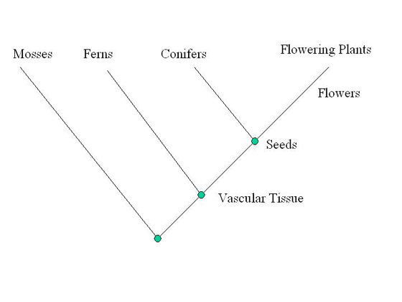
Flower Structure
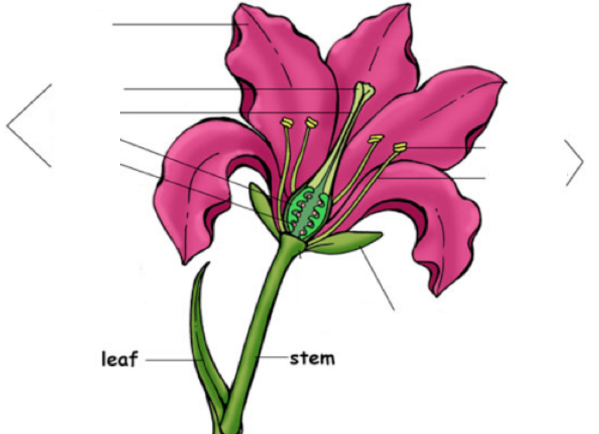
Flower Structure to Function
STUCTURE |  | SKETCH | FUNCTION
Nectar Gland
Petal
Sepal
Stamen | Anther
 | Filament
Pistil | Stigma
 | Style
 | Ovary
 | Ovule
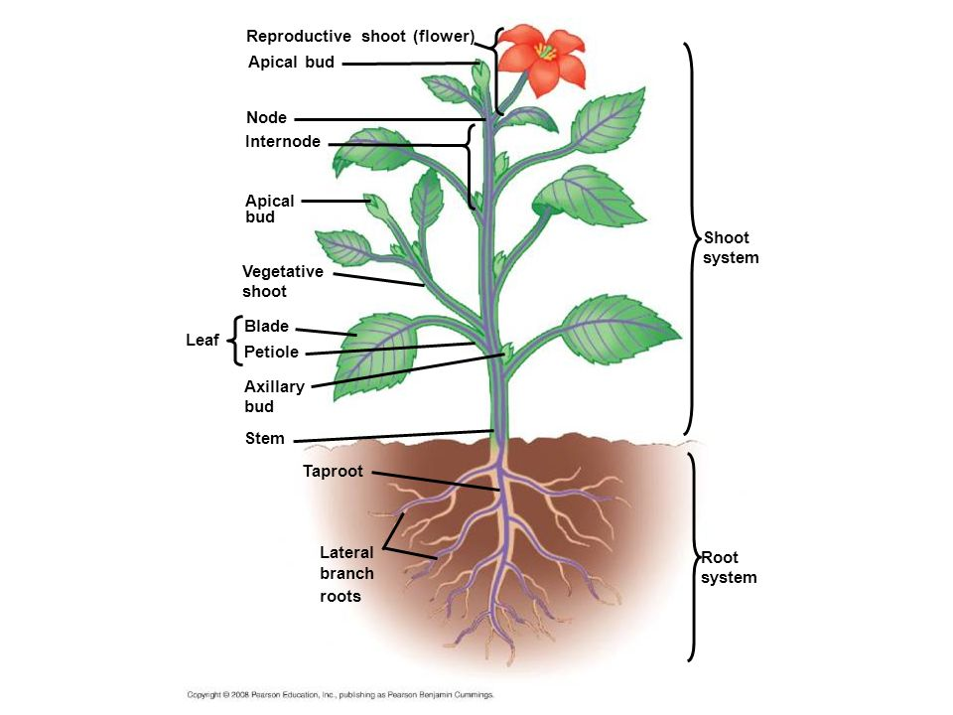
Control of Flowering
Reproductive Structures:

Flowers form from…

Vegetative Structures:

Abiotic Factors that Regulate Flowering:

Photoperiods
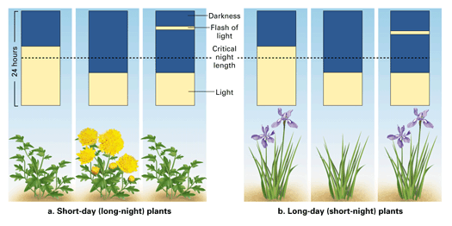

Phytochrome is a pigment within the leaves with two interchangeable forms that each elicit different responses in the plant.

Pr Pfr

Pollination and Fertilization

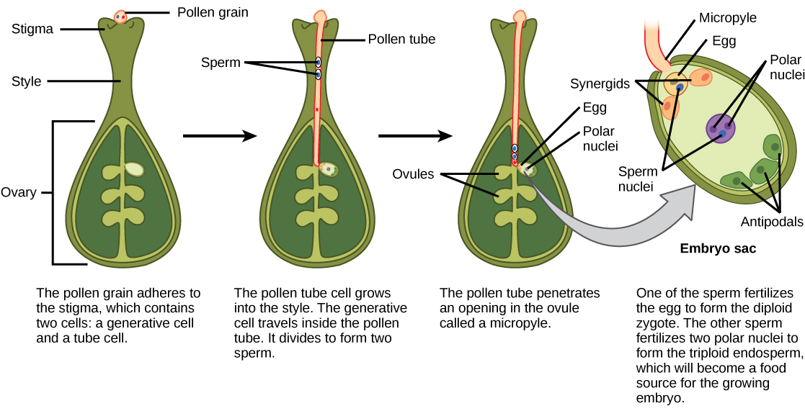
After fertilization, the ovule develops into:
After fertilization, the ovary develops into:

Seed Dispersal
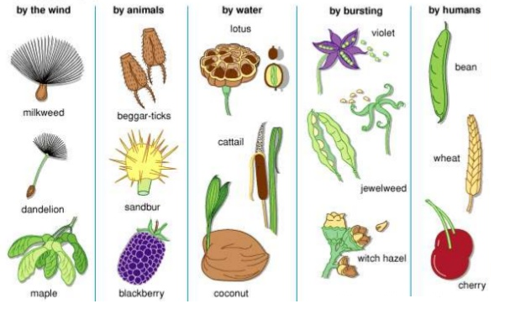

Seed Structure
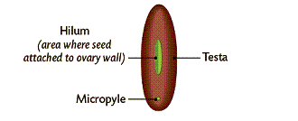
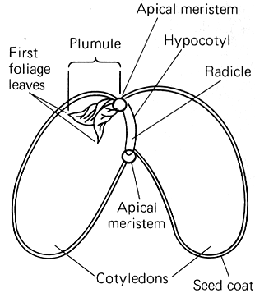
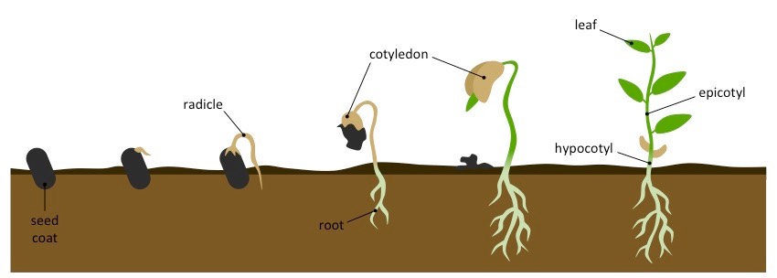
Germination
Water | Oxygen | Warmth
Gibberellin:

