IB Storyboard Activity – Immune response
These images tell the story of how lymphocytes protect the body from infection of bacteria. Write a commentary next to each image to explain the antibody response :

 |  | - An IB student has cut their finger on a sheet of difficult past paper questions. Normally the skin is a physical barrier to infection, it stops bacteria from entering the body. This cut is a way into the body for bacteria
 | 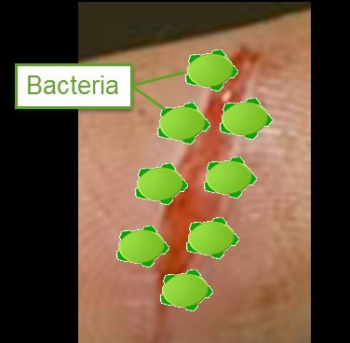 |  | - Bacteria have entered the cut but fortunately, cells of the immune system detect the bacteria? Explain the role of antigens  ..............................................................................  ...............................................................................  ...............................................................................
 | 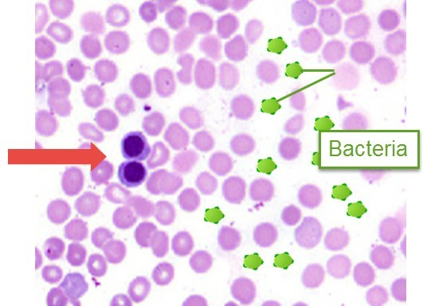 |  | - There are many cells in the blood. Two types of blood cell help the body to destroy the bacteria Name the two cell types & their functions.  ...............................................................................  ...............................................................................  ...............................................................................  ...............................................................................

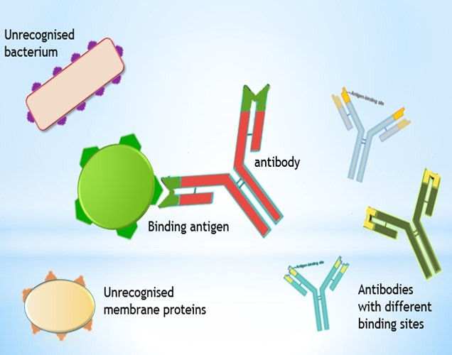 |  | - Many types of lymphocyte produce one type of antibody each. Why are there so many different types of lymphocyte in the blood?  ...............................................................................  ...............................................................................  ...............................................................................
 | Lymphocyte clones | - One type of lymphocyte produces an antibody which attaches to the antigens of the bacteria. What does it do?  ...............................................................................  ...............................................................................  ...............................................................................
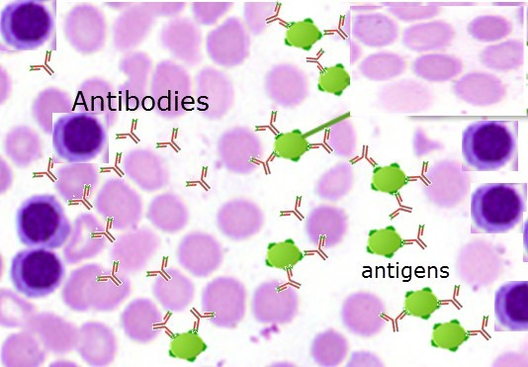 |  | - The antibodies are produced in large numbers and attach to the antigens of the bacteria. How does this help to protect the body from the bacteria?  ...............................................................................  ...............................................................................  ...............................................................................
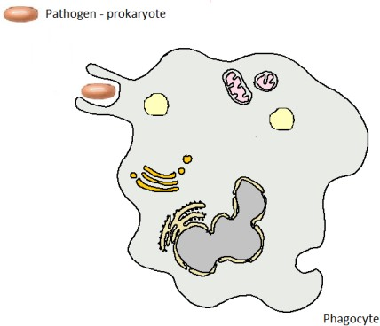 |  | - Phagocytic leucocytes to complete the destruction of the bacteria. Explain what they do.  ....................................................................  ........................................................................  ........................................................................
