- State the functions of the following components of the blood:
Lymphocytes
Phagocytic leukocytes (macrophages)
Erythrocytes
Platelets
Plasma

Use the animation and card sort game before you outline the processes:
- Outline how phagocytic leukocytes ingest pathogens in the blood and body tissues.

- Distinguish between antibodies and antigens.

Antibody | A globular protein. (revise levels of protein structure)  Produced as part of the immune response.  Specific to the antigen on the pathogen – the antigen binding site is analogous to the active site of an enzyme.
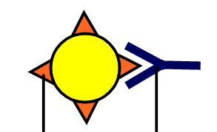
Link thought: how is this important in ABO blood typing and how is that an example of codominance?
- Explain how antibodies are produced.
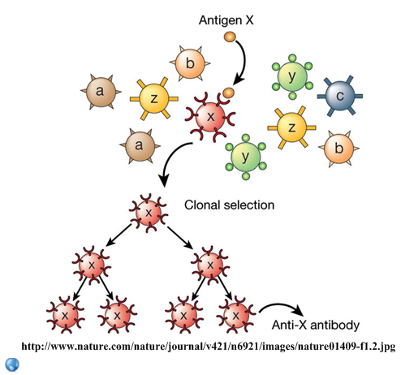 | There are many different types of lymphocytes in the immune system.

- State the role of memory cells following an infection.

- Explain why antibiotics can be used to treat bacterial infections but not viral infections.

- Outline how overuse of antibiotics is leading to antibiotic resistant strains of bacteria?

- Analyse the graph over time, outline what has happened to:
- The number of new approved antibiotics
- The diversity of new approved antibiotics
Suggest reasons for your answers

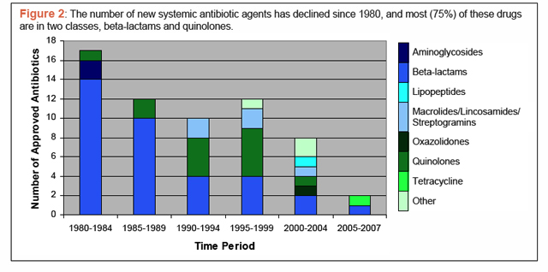
- Discuss the ways in which Florey and Chain’s work is in accord with and breaches the modern practices of drug testing.

- Define the terms HIV and AIDS
HIV =

AIDS =

- Outline the effects of HIV on the immune system.
Effect on lymphocytes
Effect on antibody production
Effect on health

- What are the risk factors in HIV transmission?

NO RISK LOWEST RISK HIGHEST RISK

Works Cited
1. Allott, Andrew. IB Study Guide: Biology for the IB Diploma. s.l. : Oxford University Press, 2007. 978-0-19-915143-1.
2. Mindorff, D and Allott, A. Biology Course Companion. Oxford : Oxford University Press, 2007. 978-099151240.
3. Clegg, CJ. Biology for the IB Diploma. London : Hodder Murray, 2007. 978-0340926529.
4. Campbell N., Reece J., Taylor M., Simon. E. Biology Concepts and Connections. San Fransisco : Pearson Benjamin Cummings, 2006. 0-8053-7160-5.
5. Taylor, Stephen. Science Video Resources. [Online] Wordpress, 2010. http://sciencevideos.wordpress.com.
6. Burrell, John. Click4Biology. [Online] 2010. http://click4biology.info/.
7. IBO. Biology Subject Guide. [Online] 2007. http://xmltwo.ibo.org/publications/migrated/production-app2.ibo.org/publication/7/part/2/chapter/1.html.

Self Assessment:
 | Essential Biology |  |  | Assessment
Criterion | Complete (2) | Partially complete (1) |  | Self | MrT
Presentation & Organisation | NA | Complete and neat. All command terms highlighted, tables and diagrams well presented.
Academic Honesty | NA | Sources cited using the CSE (ISO 690 numerical) method, with Works Cited section complete and correct.
Objective 1 understanding | All answers for the following command terms correct: | Most answers for the following command terms correct:
 | Define Draw Label List Measure State
Objective 2 understanding | All answers for the following command terms correct: |  | Most answers for the following command terms correct:
 | Annotate Apply Calculate Describe Distinguish Estimate Identify Outline
Objective3  understanding | All answers for the following command terms correct: |  | Most answers for the following command terms correct:
Analyse Comment Compare Construct Deduce Derive Design Determine Discuss
Evaluate Explain Predict Show Solve Sketch Suggest
Logic, notation, mathematical working | NA | Answers are presented in a logical and concise manner. SI units used most times, with correct unit symbols and definitions of terms. All mathematical working shown.
Further research | NA | Evidence is apparent of research and reading beyond the textbook and presentations to find correct answers to challenging questions. If any questions are unanswered, this criterion scores zero.
 | Total (max 10):

