HIV and AIDS

Watch this short animation:
- HIV & AIDS explained in a simple way

Watch this second video which shows the way T-lymphocytes work in the immune system:
- HIV and T-lymphocytes
Make notes here as you watch the video:

Now turn over and answer the questions on the worksheet, you may want to watch the videos again as you formulate your answers.

HIV infection – reduces the active lymphocyte number

Write answers in the spaces next to the images in the table below.
These points summarise the effects of HIV infection on the immune system

What is HIV?  ..............................................................................  ..............................................................................  Which cells in the blood does it infect?  ..............................................................................  .............................................................................. | 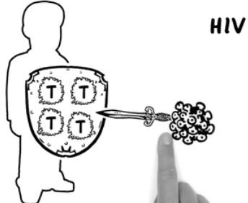
Outline how viruses (including HIV) replicate?  ..............................................................................  ...............................................................................  ...............................................................................  ............................................................................... | 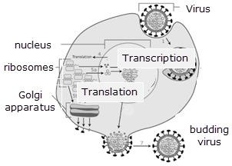
State the roles of the two chemicals which helper T-cells produce  ...............................................................................  ...............................................................................  ...............................................................................  ............................................................................... | 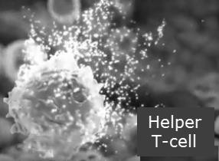

1

When there is an infection in the body Helper T- cells cause a type of B-Lymphocyte to multiply.  What protein do these ‘activated’ lymphocytes then produce?  ...............................................................................  ............................................................................... | Lymphocyte clones
If the lymphocytes don’t get the signals from the helper T-cells what happens to the number of antibodies?  ...............................................................................  ...............................................................................  ............................................................................... | Antibodies bind to pathogens
Once the body has too few helper T-cells and the immune system is slower to respond what other problems can affect the body?  ...............................................................................  ...............................................................................  ............................................................................... | Bacteria growing on cells
Explain what AIDS is?

....................................................................

........................................................................
