The aim of this activity is to set up some simple transpiration experiments and to make them work. Then to plan how to use it for an investigation.

Activity 1- Choose your apparatus – an experiment circus

Pipette & tube potometer  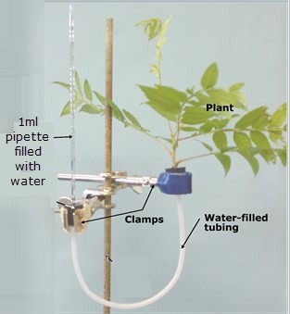  Under water in a bowl or sink, connect a branch to one end of the tube and a 1ml graduated pipette to the other. Vaseline and clamps may help to seal. | Filter paper potometer  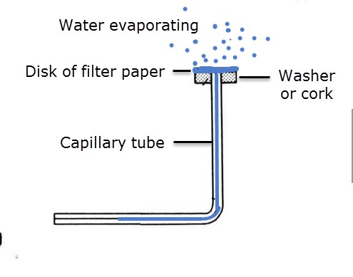  Soak a piece of filter paper. Attach a plumbing washer or rubber bung to one end of the capillary tube. Sit the wet paper on the top ensuring it touches the water in the tube. Watch the bubble move along the capillary. | Traditional Lab potometer  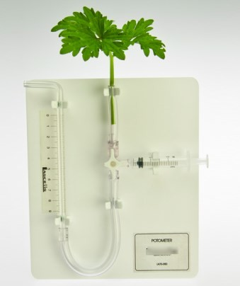  Under water connect a branch to the tube and draw water into the syringe. Careful use of the 3 way taps is needed.
Plastic bag potometer  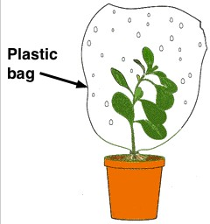  Measure the mass of a plastic bag accurately. Attach the bag over the top of a plant and wait. Measure the mass again after a given time. | Celery and oil potometer  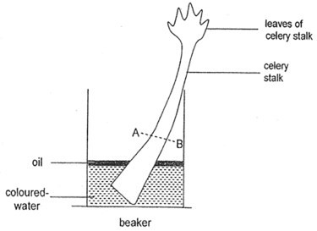  Cut the base of a stalk of celery under water. Cover the surface of the water in a layer of cooking oil. At the end of the experiment measure the distance the water has moved up the xylem of the celery by slicing across the stem. | Balance potometer  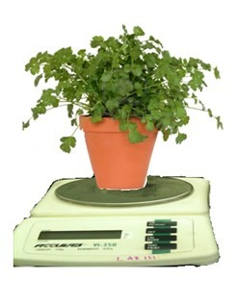  Measure the mass of a plant accurately using an electronic balance. Size of plant must not be too big. Record the mass again over time.

Method
- Each student sets up one piece of apparatus and records any starting data on a piece of paper which stays with the apparatus. See details in the table below.
- After the setup time, students rotate one place and begin to record data or repair equipment of their neighbour which is not working.
- After the first ten minutes of data recording, students estimate the uncertainties of the apparatus and rotate one place.
- Again after ten minutes of data collection students record uncertainties and limitations and rotate one place.
- Continue repeating step 4 until each student has an opportunity to test each of the simple sets of apparatus.
- To end the activity students return to their original place and collect the sheet containing data, uncertainties and limitations.

All of these sets of apparatus require good manipulative skills to make them work. Which sets of apparatus seemed to work best?

…………………………………………………………………………………………………………………………………………….
…………………………………………………………………………………………………………………………………………….
…………………………………………………………………………………………………………………………………………….

Which apparatus was the most problematic, explain why?
…………………………………………………………………………………………………………………………………………….
…………………………………………………………………………………………………………………………………………….
…………………………………………………………………………………………………………………………………………….
…………………………………………………………………………………………………………………………………………….

Activity 2 – Choose your variables
In the IB guide students are asked to investigate one of two possible independent variables:

  - the temperature, or
  - the humidity.

Both of these variables are difficult to manipulate while controlling other variables. This is part of the challenge of being a biologist. Try to design a way to change these variables for one of the sets of apparatus from activity 1.
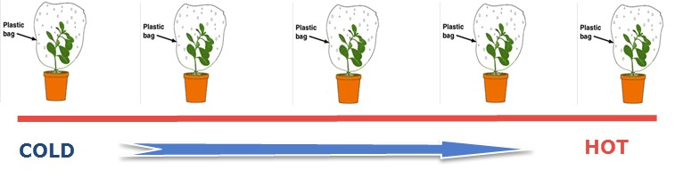

- How is it possible to set up an experiment to investigate five different temperatures?
…………………………………………………………………………………………………………………………………………….
…………………………………………………………………………………………………………………………………………….
…………………………………………………………………………………………………………………………………………….
…………………………………………………………………………………………………………………………………………….

- How to set up an experiment to investigate five different humidities?
…………………………………………………………………………………………………………………………………………….
…………………………………………………………………………………………………………………………………………….
…………………………………………………………………………………………………………………………………………….
…………………………………………………………………………………………………………………………………………….

Activity 3 – Design a data set and collect the data

Use one of your experiment designs from activity two for this activity.

What type of graph will be needed to show any relationships between the variable which is deliberately changed (the independent variable) and the variable which has been measured?

Sketch a graph as an example.

How many results will be needed to draw this graph?

…………………………………………………………………………………………………………………………………………

What size will be the smallest and largest values of the variable you changed in the experiment?
…………………………………………………………………………………………………………………………………………

Sketch a results table in the space below that could be used to collect the data from this experiment.

Finally, note any hazards and precautions which need to be taken in the experiment.
…………………………………………………………………………………………………………………………………………
…………………………………………………………………………………………………………………………………………
………………………………………………………………………………………………………………………………………..

