Transpiration
What does a xylem cell look like?
How dos it prevent itself from being crushed?

Drawing the structure of primary xylem vessels
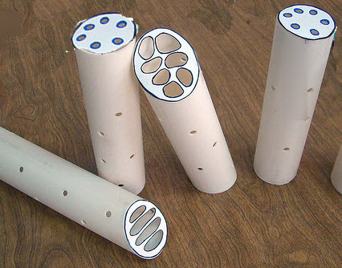
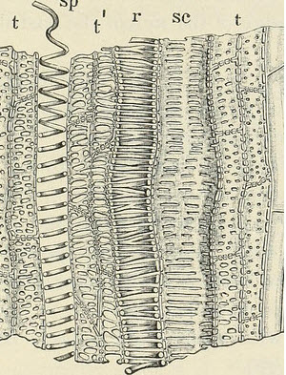
There are many different appearances of xylem vessels but they all have the same key features. Cell walls thickened with rings or spirals of a chemical called lignin, holes of varying shapes in the cell walls and no cytoplasm (they are dead cells).
Using the images above and this video to draw a diagram to represent the structure of a primary xylem vessel:

Using the Hexagon cards, make sense of the key concepts in transpiration.
Cut out the hexagons and do the following:
- Arrange then in groups of similar cards
- Annotate each one to make sense of its meaning
- Link them to each other and use these linked cards to create your own explanations of how water flows in the transpiration stream.
Share ideas and record explanations
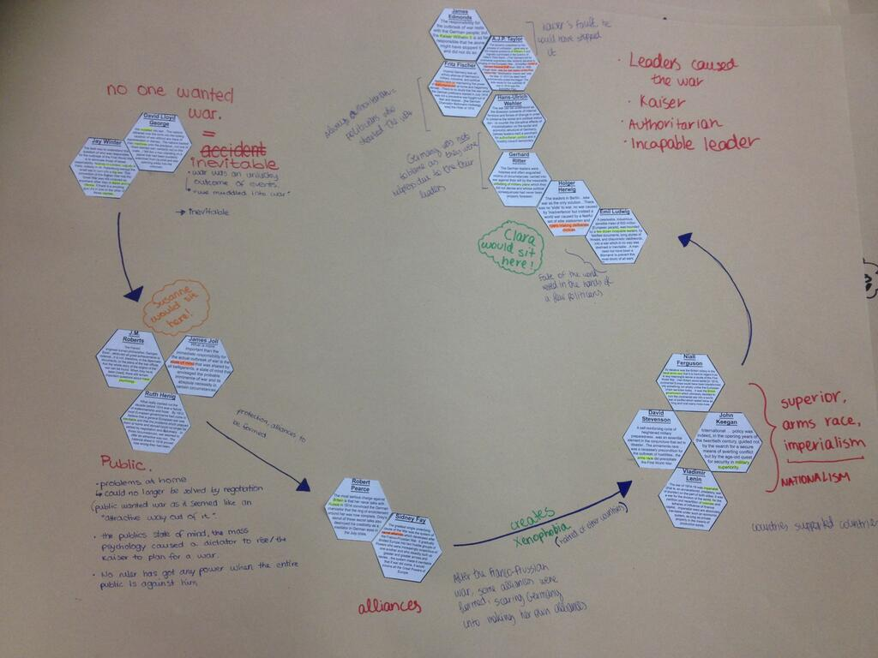
Explain your diagrams to a partner by telling the key point they chose about the nature of science.
Options include:
- Stick the hexagons on paper and write notes around them.
- Video each other as they give the explanation.
- Take photographs and build a PowerPoint presentation / or worksheet.

