Respiration introduction – IB style questions
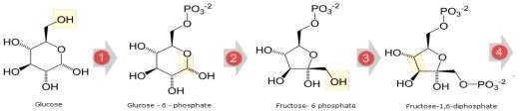

The diagram above shows the first steps of the process of glycolysis Use this diagram to answer to help you answer questions 1 & 2.

- Which of the numbered steps shows a phosphorylation reaction?
  - Step 1 only
  - Step 2 and step 3
  - Step 1 and step 4
  - Step 1 and step 3

- What is the best biological term to describe a chain of enzyme-controlled reactions?
  - Catalysed reactions
  - Metabolic pathway
  - Enzyme metabolism
  - Phosphorylation pathway

Questions 3 to 5 refer to the following steps of the same biological process.
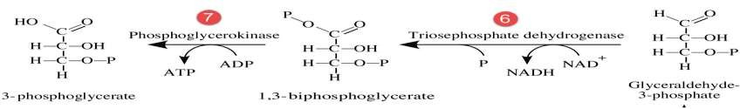

- Which of the molecules shown in the diagram is reduced?
  - NAD⁺
  - NADH
  - Glyceraldehyde-3-phosphate
  - ADP
- Which of the molecules shown in the diagram is oxydised?
  - NAD⁺
  - NADH
  - Glyceraldehyde-3-phosphate
  - ADP
- Which of the molecules shown in the diagram is phosphorylated?
  - ATP
  - NADH
  - Glyceraldehyde-3-phosphate
  - NAD⁺

1

