IB style questions on transpiration and xerophytes

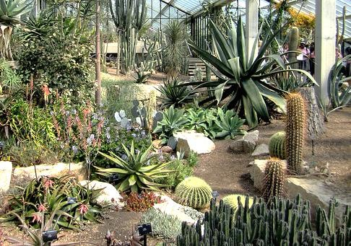
The image above shows the desert ecosystem at the New York botanical gardens
- Describe the harsh environment found in deserts or on beaches with reference to light, temperature, wind and humidity.
………………………………………………………………………………………………………………………………………………………
……………………………………………………………………………………………………………………………………………………..
………………………………………………………………………………………………………………………………………………………
……………………………………………………………………………………………………………………………………………………..

- Explain how the abiotic factors in deserts or on beaches affect the rate of transpiration in a typical terrestrial plant.
………………………………………………………………………………………………………………………………………………………
……………………………………………………………………………………………………………………………………………………..
………………………………………………………………………………………………………………………………………………………
……………………………………………………………………………………………………………………………………………………..
………………………………………………………………………………………………………………………………………………………

1

- Name two adaptations of xerophytes and explain how they reduce transpiration rates?
………………………………………………………………………………………………………………………………………………………
……………………………………………………………………………………………………………………………………………………..
………………………………………………………………………………………………………………………………………………………
……………………………………………………………………………………………………………………………………………………..
………………………………………………………………………………………………………………………………………………………
……………………………………………………………………………………………………………………………………………………..

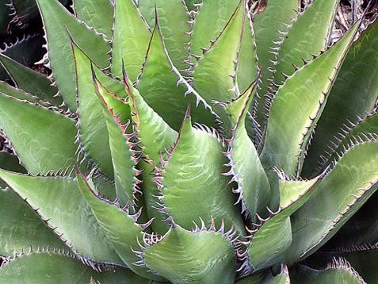
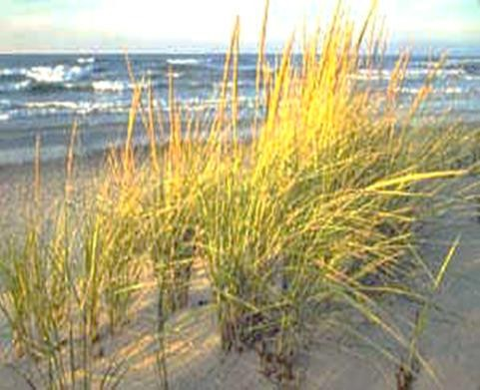
Agave and Marram grass – two xerophytic plants

- The agave and marram grass shown in the box above have different ways of avoiding water loss. Compare the xerophyte features of these two plants.
………………………………………………………………………………………………………………………………………………………
……………………………………………………………………………………………………………………………………………………..
………………………………………………………………………………………………………………………………………………………
……………………………………………………………………………………………………………………………………………………..
………………………………………………………………………………………………………………………………………………………
……………………………………………………………………………………………………………………………………………………..

2

