Phloem - structure and function

Annotate the diagrams to explain phloem structure and function
Explanations
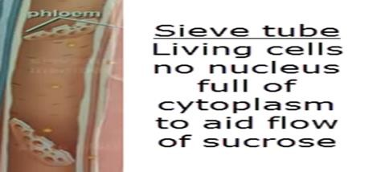
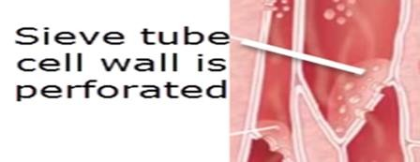
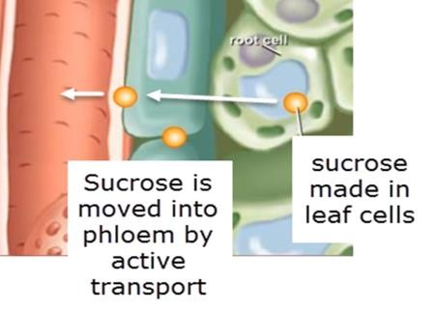
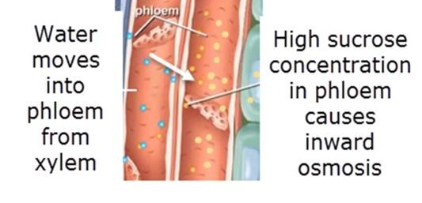
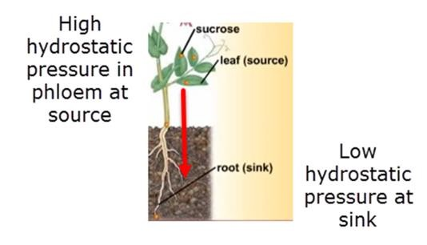
- Sieve tube cells in phloem
Images to explain
a)
b)
c)
d)
e)
…………………………………………………………………
…………………………………………………………………
……………………………….………………………………..
………………………………………………………………….
………………………………………………………………….
- Sieve plates
…………………………………………………………………
…………………………………………………………………
……………………………….………………………………..
………………………………………………………………….
………………………………………………………………….
- Sucrose moved into phloem at source
…………………………………………………………………
…………………………………………………………………
……………………………….………………………………..
………………………………………………………………….
………………………………………………………………….
- Osmosis
…………………………………………………………
…………………………………………………………………
……………………………….………………………………..
………………………………………………………………….
………………………………………………………………….
- Phloem contents flow towards sink
…………………………………………………………………
…………………………………………………………………
……………………………….………………………………..
………………………………………………………………….
………………………………………………………………….

1

