Topic 6: Biochemistry of Life Part 1- Water

IB Assessment statements |  | Unit objectives:
2.1.U1  2.2.U2  2.2.U3  2.2.A1  2.2.A2  2.2.A3  2.2.NOS | Water molecules are polar and hydrogen bonds form between them.  Hydrogen bonding and dipolarity explain the cohesive, adhesive, thermal and solvent properties of water (give at least 1 example of a benefit to living organisms).  Substances can be hydrophilic or hydrophobic.  Comparison of the thermal properties of water with those of methane.  Use of water as a coolant in sweat.  Modes of transport of glucose, amino acids, cholesterol, fats, oxygen, and sodium in blood in relations to their solubility in water.  Use of theories to explain natural  phenomena- the theory that hydrogen bonds form between water molecules explain the properties of water | Basics of Biochemistry  - Describe the structure of an atom (in terms of protons, neutrons and electrons).  - Contrast ion with atom.  - Define anion and cation.  - Contrast covalent, ionic and hydrogen bonds.  Water  - Write the molecular formula for water and draw the atomic structure of the molecule.  - Describe the cause and effect of the polar nature of water.  - Describe where and how water is able to form hydrogen bonds.  - Contrast adhesion with cohesion.  - Explain why it takes so much energy to change the temperature of water.  - Describe the benefits to life of waters high heat capacity.  - Explain why is water such a good solvent and explain the types of molecules will it dissolve.  - Define hydrophilic and hydrophobic.  - Compare the thermal properties of water and methane.  - Explain why water and methane have different thermal properties based on their atomic structure.

1
Basics of Biochemistry
Neutrons:
In the atomic nucleus, which provides…
Protons:
Electrons:
Electrons interact with…
Cations:
Anions:
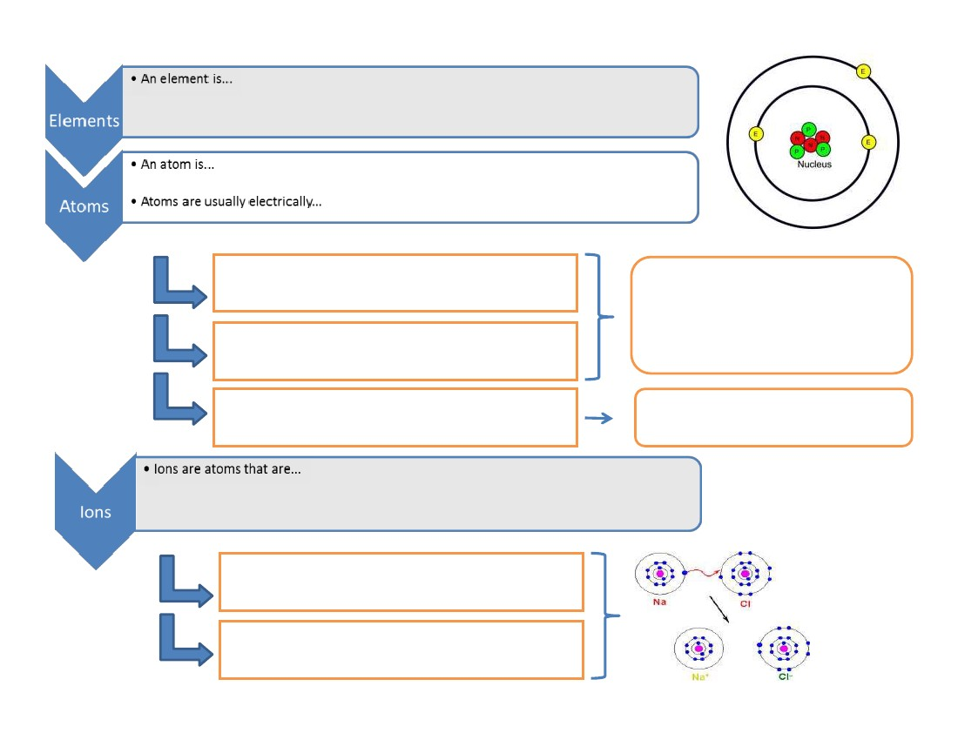
2
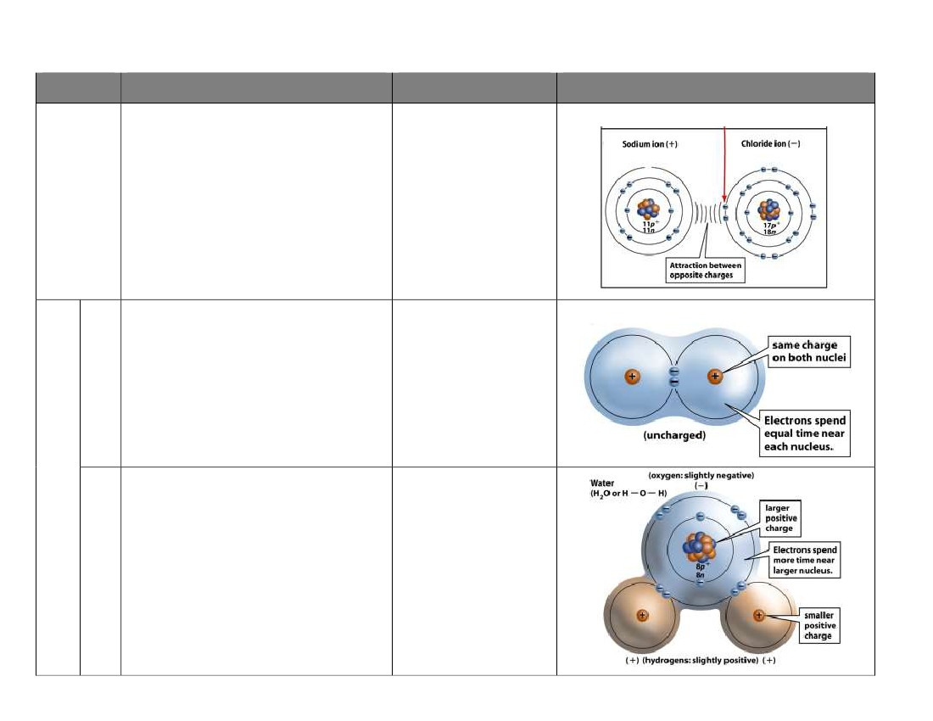
Chemical Bonds: holding molecules together
Type
Description
Example
Diagram
Ionic bond
Covalent bond
Polar
Non-
polar
3
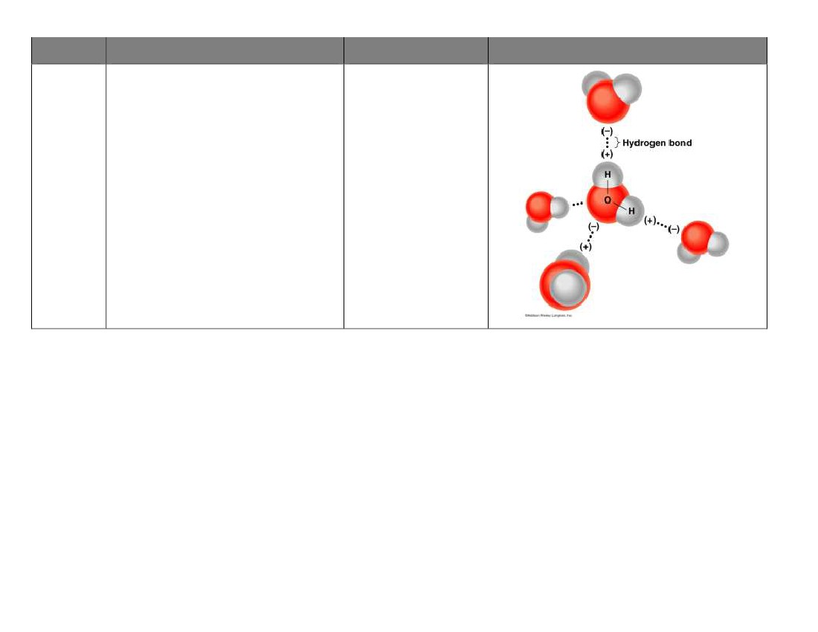
Type
Description
Example
Diagram
*actually an intermolecular force, not a true bond. But, the name is the name.
VIDEO GUIDE FOR BOZEMAN BIOLOGY – CHEMICAL BONDS: IONIC VS. COVALENT
What are chemical bonds?
How are covalent bonds different from ionic bonds?
What are the two types of covalent bonds?
How do we know that water has polar covalent bonds?
Hydrogen “bond”*
4
VIDEO GUIDE FOR BOZEMAN BIOLOGY – WATER AS A POLAR MOLECULE
Oxygen is unique because__________________________
Why does water behave like a magnet?
The bond between oxygen and hydrogen within a water molecule is a _____________ bond
The bond between oxygen and hydrogen on different water molecules is a _________ bond
Draw the hydrogen bonds between the five water molecules show at 3:48 (pause the video here)!
________________ is a polar molecule, ______________________ is a nonpolar molecule.
Describe the five properties of water that are due to its polarity
Property
High specific heat
Description
“real life” application of this property
Solvent
Cohesion
Capillary action
Ice floats
Why is Seattle warmer in the winter than Yellowstone, even though both locations are at similar latitudes?
How does water get to the top of a tree?
Why is it “good” for aquatic organisms that live in cold climates that ice floats?
5
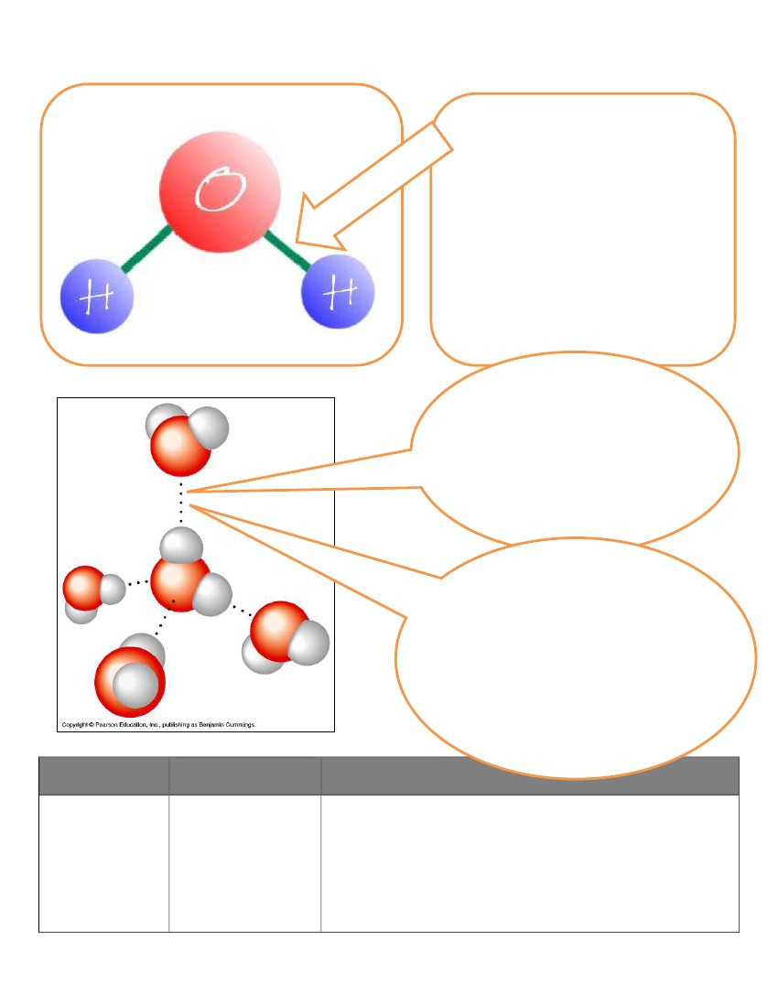
Water, Water Everywhere
Structure of Water
Water molecules are polar
•
The e- are…
•
The oxygen atom…
•
Results in:
Water molecules can form hydrogen “bonds”
Partially ____________
_______________ atoms of one water
molecule are attracted to the partially
______________ _____________
atom of another water molecule
.
The bonds are ________ and
________________ quickly as the
_______________ ____________,
however the _________ __________
of ____________ contribute to the
_______________ of water.
BIOLOGICALLY IMPORTANT PROPERTIES OF WATER
Significance Explanation
Property for Life

ICE FLOATS
Ice floats and insulates the
underlying water so many
plants and animals are not
frozen
6
Property
Significance
for Life
Water is the main
transport medium for
dissolved nutrients. In
animals, blood (mostly
water) goes through out
all parts of the body,
carrying nutrients. In
plants, water carries
nutrients up plants and
through leaves.
Cohesion explains how
water molecules can form
a chain in delivering
moisture to the top of a
tree or through the blood
stream
Explanation
SOLVENT
COHESION
Cohesion of water molecules along a surface produces SURFACE TENSION
ADHESION
Adhesion helps water
climb up the thin tubes of
plants to the leaves
Adhesion and cohesion of water allows for CAPILLARY ACTION
HIGH SPECIFIC
HEAT
Contents of cells are
unlikely to freeze. Aquatic
environments are
thermally stable.
Organisms have stable
internal temperatures
when the external
temperature is
fluctuating.
HIGH HEAT OF
VAPORIZATION
Organisms rely on hear of
vaporization to remove
body heat to remain cool.
Evaporative cooling.
7
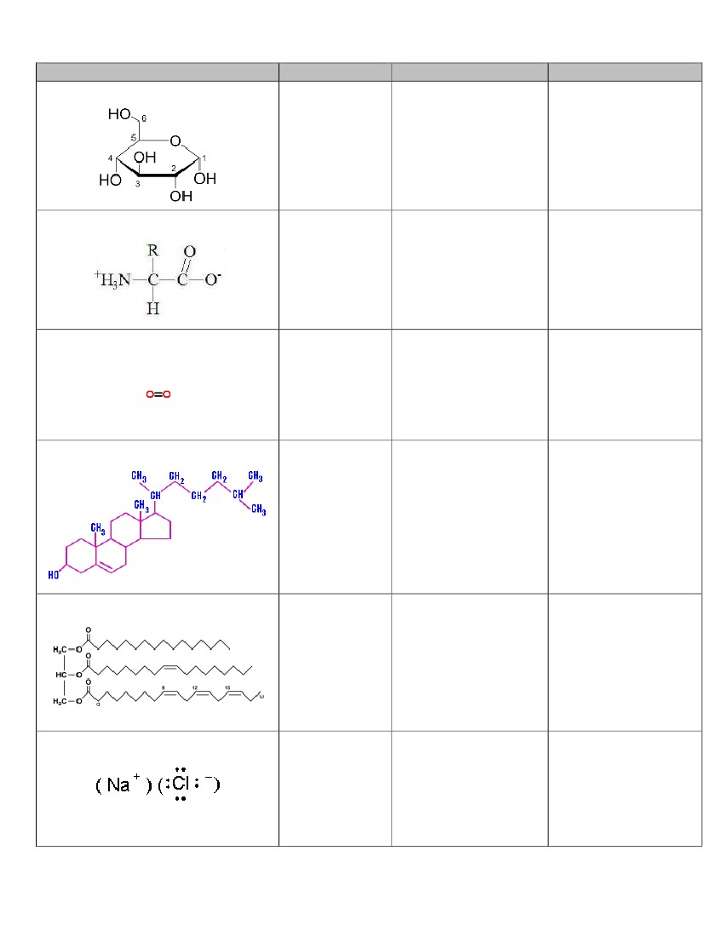
SOLUBILITY IN WATER
MOLECULE
Glucose
-PHILIC/-PHOBIC
EXPLANATION
IMPLICATION
Amino Acid
Oxygen
Cholesterol
Fat
Sodium Chloride (salt)
8
COMPARING
WATER TO
METHANE
FORMULA
BONDING
POLARITY
DENSITY
METHANE
WATER
HEAT CAPACITY
HEAT OF VAPORIZATION
MELTING POINT
BOILING POINT
9

