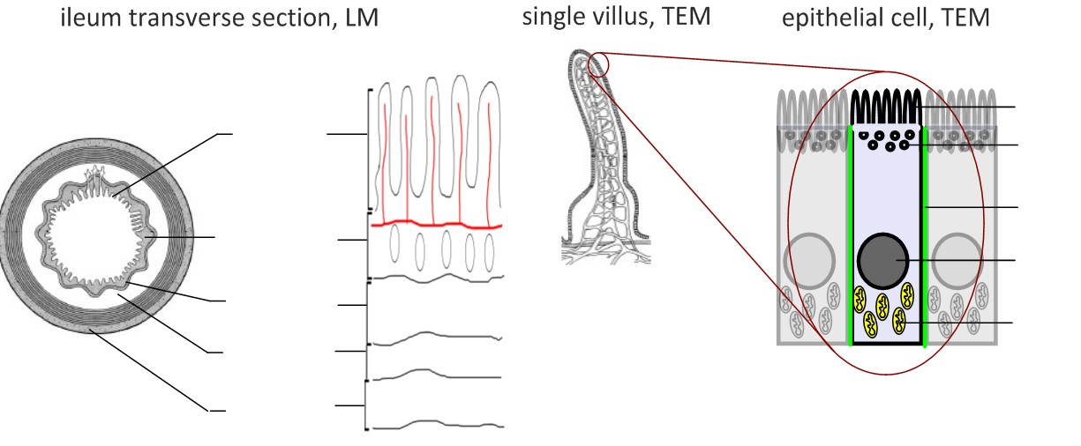

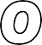
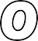
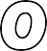
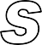
Labels: villi, mucosa, submucosa, circular and longitudinal muscle. What is the role of the circular and longitudinal muscle?
What are the functions of these parts of the villus cell? Microvilli
Pinocytic vesicles Tight junction Mitochondria

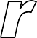
Water | Fats | Fructose | Monosaccharaides & Amino Acids | Polypeptides
Uptake:  Simple diffusion (osmosis) | Uptake: | Uptake: | Uptake: | Uptake:
Transport:  Carried in the blood | Transport:  Chylomicrons deliver lipids to the lymph vessels by exocytosis | Transport: | Transport: | Transport:
Diagram & Explanation: | Diagram & Explanation: | Diagram & Explanation: | Diagram & Explanation: | Diagram & Explanation:
Structural adaptations:  Water is small enough to pass between the phospholipids of the plasma membrane. Large surface area due to microvilli. | Structural adaptations:  Lipids pass easily through the phospholipid bilayer. Large sur- face area due to microvilli. Lots of endoplasmic reticulum to make lipoproteins (chylomicrons) | Structural adaptations: | Structural adaptations: | Structural adaptations:
Notes: | Notes: | Notes: | Notes: | Notes:
List that materials which are egested in faeces:

