Rates of Enzyme controlled reactions

Aims:
- To demonstrate some methods of studying rates of enzyme catalysed reactions.
- To look at the effects of pH, temperature and substrate concentration on the rate of hydrogen peroxide breakdown in the presence of the enzyme catalase.

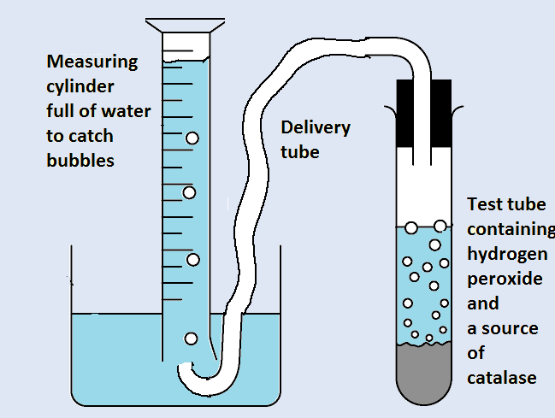
Introduction

One of the easiest methods of measuring rates of reaction is to measure the production of the products of that reaction.

A common way to do this in reactions which produce a gas is by collecting the gas produced.

A simple inverted measuring cylinder filled with water over a water trough works well.

Hypothesis

The breakdown of hydrogen peroxide into water and oxygen will happen more quickly when:

- the concentration of substrate is higher
- the pH is closest to the optimum pH of the catalase (near pH7.0 in humans)
- the temperature is closest to the optimum temp. (near 37°C in humans)

Apparatus

Safety
Wear eye protection Tie back long hair
Equation of the breakdown
Hydrogen peroxide
2H2O2
reactant
Catalase
⎯⎯⎯→
Water + Oxygen
2H2O O2
products
- A source of catalase; powdered yeast
- 5 cm3 syringe / pipette
- Dropping pipette
- 25ml Measuring cylinder
- Water bath set to 80°C
- Stopwatch
- Solutions of Hydrogen peroxide (20Vol, 15Vol, 10Vol, 5Vol, and 0Vol)
- Access to an electronic balance
- Access to buffers of pH 2,4,6,8,10
- Access to water baths of 10, 30, 50, 70, and 90 °C

Method A: Measuring the Rate of the Reaction

- Measure 0.1g of yeast powder using an electronic balance. The yeast cells contain the enzyme catalase.
Safety
Wear eye protection.
Rinse any splashes off your skin.
3
- Measure 5 cm of 20 volume hydrogen peroxide into
a boiling tube.
- Set up the inverted measuring cylinder as in the diagram above.
- Add the yeast to the boiling tube and quickly connect the tube to the rest of the apparatus.
- Every 10 seconds, record the volume of oxygen until the bubbles stop.

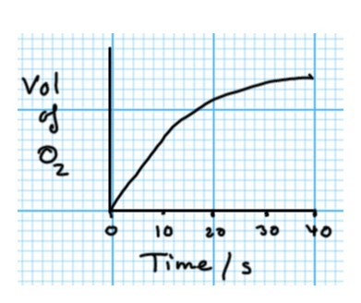
Results

If you sketch a quick graph, you may notice that the graph is not a straight line. The rate of reaction is not constant; the reaction is slowing down as the hydrogen peroxide is broken down.

The concentration of substrate seems to affect the rate of the reaction.

Method B: Measuring the Rate with different concentrations of substrate (Hydrogen Peroxide)
- Measure five 0.1g samples of yeast powder using an electronic balance and keep them on carefully folded pieces of paper (or in dry test tubes).
- Measure 5 cm3 of each of five different concentration of hydrogen peroxide into five separate boiling tubes. Label each tube.
- Set up the inverted measuring cylinder as before.
- Add the yeast to the first boiling tube and quickly connect the tube to the rest of the apparatus.
- After 1 minute record the volume of oxygen which has been produced.
- Repeat for each of the five concentrations of substrate, hydrogen peroxide.

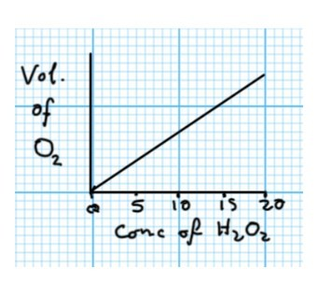
Results

If you sketch a quick graph, is the graph a straight line? Is the rate of reaction constant?

Method C: Measuring the Rate with different pH of solution

- Measure five 0.1g samples of yeast powder once more.
- Measure 5 cm3 of 20Vol hydrogen peroxide into five separate boiling tubes.
- Label each tube; pH2, pH4, pH6, pH8, pH10 and add five drops of buffer for each pH
- Set up the inverted measuring cylinder as before.
- Add the yeast to the first boiling tube and quickly connect the tube to the rest of the apparatus.
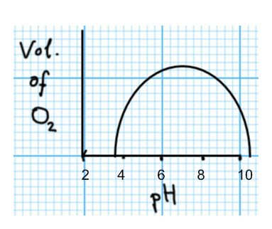
- After just 30 seconds, record the volume of oxygen.
- Repeat for each of the five different pHs.

Results

If you sketch a quick graph, does the shape show an “optimum” peak. What is the pH of this?

Method D: Measuring the Rate at different temperatures

- Measure five 0.1g samples of yeast powder once more.
- Measure 5 cm3 of 20Vol hydrogen peroxide into five separate boiling tubes.
- Label each tube; 10°C, 30°C, 50°C, 70°C and 90°C and put each boiling tube into a water bath for 5 minutes. Check the temperature with a thermometer.
- Set up the inverted measuring cylinder as before.
- Add the yeast to the first boiling tube and quickly connect the tube to the rest of the apparatus.
- After just 10 seconds, record the volume of oxygen.
- Repeat for each of the five temperatures of hydrogen peroxide.

Results
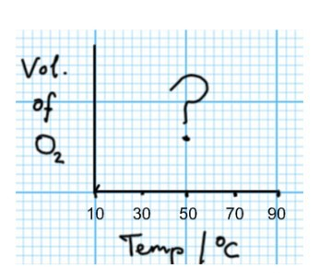
If you sketch a quick graph, what does the shape show?

Do you notice any change in the hydrogen peroxide solutions during their treatment in the water bath?

Conclusion & Evaluation

Did your experiments show the expected patterns?

………………………………………………………………………………………………………………………………………………………….

………………………………………………………………………………………………………………………………………………………….

………………………………………………………………………………………………………………………………………………………….

…………………………………………………………………………………………………………………………………………………………. Describe any limitations to the accuracy of these experiments.
………………………………………………………………………………………………………………………………………………………….

………………………………………………………………………………………………………………………………………………………….

………………………………………………………………………………………………………………………………………………………….

………………………………………………………………………………………………………………………………………………………….

Suggest improvements for each limitation. The three diagrams below show different apparatus for the same experiment. Why I each one an improvement on the experimental technique you have just used?










