Digestion
- Define the following terms, giving an example of each.
Macromolecule | “large molecules made up of smaller organic molecules. There are four classes of macromolecules: carbohydrates, lipids, proteins and nucleic acids” ⁽¹⁾
Ingestion
Digestion
Absorption
Assimilation
Excretion
Egestion
Enzyme
Substrate
Optimum pH
Lipase
Protease
Amylase

- Explain the need for digestion of large food molecules. (3 marks)

- State the name of the type of reaction which uses water to break down a macromolecule.

- Explain the need for enzymes in digestion of large food molecules. (5marks)

- Review: Explain three factors that affect the rate of enzyme activity. (8 marks)

- State the source, substrate, products, and optimum pH for the following types of enzymes:
 | Carbohydrase (amylase) | Lipase | Protease
Substrate | Carbohydrates | Lipids/ fats | Proteins
Example of enzyme |  |  | trypsin
Product(s)
Source of enzyme |  | pancreas
Optimum pH
- Label and state the function of the structures of the digestive system below:
 | Name | Function | 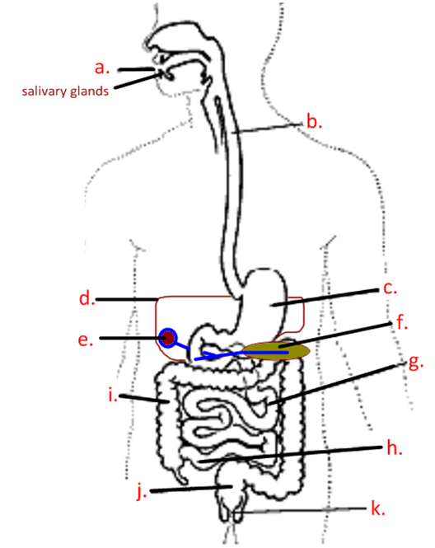
a.
 | Salivary glands | Secrete saliva, includes amylase to being digestion of starch.
b.
c.
d.
e.
f.
g. | Small intestine (duodenum)
h.
i.
j.
k.

- Outline the functions of the stomach and small intestine.

Stomach
Acid
Mechanical Digestion
Enzyme

Small intestine
Neutralisation of chyme
Enzymes
Duodenum
Ileum
Peristalsis
- The small intestine is made up of many finger-like projections called villi.
- Distinguish between absorption and assimilation.

- Label the structures of the villus below.
- Explain how the structure of the villus is related to its role in absorption and transport of the products of digestion.

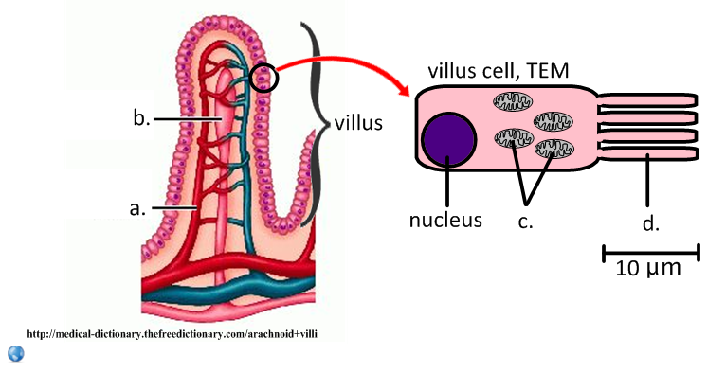
Visible structures |  | Function/ effect
 | Villi | Increase surface area for absorption
a.
b.
Not visible (epithelial cells) |  | Function/ effect
 | Epithelium is one cell thick | Short diffusion path of molecules from lumen into blood
c.
d.
 | Protein channels in microvilli | Channels for:  Pumps for:
- Undigested food molecules are passed to the large intestine.
- Outline the functions of the large intestine.
Large intestine
Folds and Villi
Egestion

- Distinguish between egestion and excretion.

- List four materials that are egested in feces.

- Discuss the benefits of a high-fibre diet.

