Topic 6: Biochemistry of Life Part 2- Macromolecules

Essential Idea(s):
Compounds of carbon, hydrogen and oxygen are used to supply and store energy.

IB Assessment statements |  | Unit objectives:
2.1.U1  2.1.U2  2.1.U3  2.1.U5  2.1.U6  2.1.A1  2.1.NOS | Molecular biology explains living processes in terms of the chemical substances involved.  Carbon atoms can form four covalent bonds allowing a diversity of stable compounds to exist.  Life is based on carbon compounds including carbohydrates, lipids proteins and nucleic acids.  Anabolism is the synthesis of complex molecules from simpler molecules including the formation of macromolecules from monomers by condensation reactions.  Catabolism is the breakdown of complex molecules into simpler molecules including the hydrolysis of macromolecules into monomers.  Urea as an example of a compound that is produced by living organisms but can also be artificially synthesized  Falsification of theories= the artificial synthesis of urea helped to falsify vitalism | - Define “molecular biology”  - Define “organic” in relation to chemistry.  - Explain the role of carbon in organic chemistry.  - Recognize common functional groups.  - Draw the molecular structure of urea.  - Describe how urea can be synthesized by living and artificial mechanisms.  - Define vitalism and explain the role of urea in its falsification.  - List the four major types of bio-molecules.  - Contrast anabolism and catabolism.  - Describe condensation (dehydration synthesis) and hydrolysis reactions.  - Define monomer and polymer.

MOLECULAR BIOLOGY: what and why?

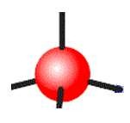
Organic vs. Inorganic Chemistry

ORGANIC: INORGANIC:

Hydrocarbons: combinations of carbon and hydrogen
• Non-polar

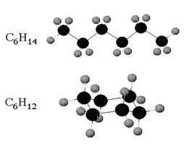
o o
• Stable

•

Functional Groups: parts of organic molecules that are involved in chemical reactions
Functional  Group | Formula / Sketch | Example
Hydroxyl
Carbonyl
Carboxyl
Amine
Phosphate

Give organic molecules distinctive properties

Affect reactivity
•

•

Carbon atoms are versatile building blocks

VITALISM

UREA

Synthesis in a Living Organism Artificial Synthesis

How urea synthesis helped to falsify vitalism:
Organic Molecule Synthesis

Biomolecules are (chains) of subunits called

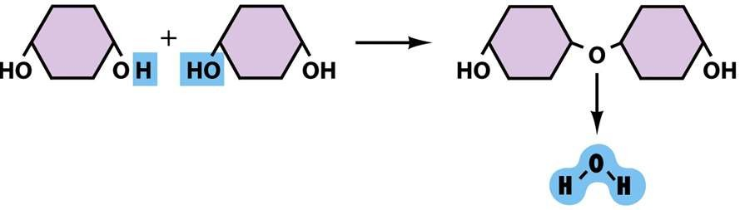
ANABOLISM: monomers are joined together through CONDENSATION REACTIONS

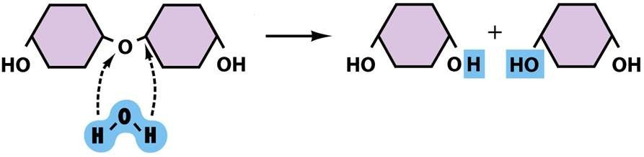
CATABOLISM: polymers are broken apart through HYDROLYSIS

All biological molecules fall into one of four categories:
Class of Molecule | Principle Subtypes | Example
Carbohydrate | Monosaccharide
 | Disaccharide
 | Polysaccharide
Lipid | Triglyceride
 | Wax
 | Phospholipid
 | Steroid
Protein | Polypeptide
Nucleic acid | Long Chain
 | Single nucleotides

VIDEO GUIDE FOR BOZEMAN BIOLOGY – BIOLOGICAL MOLECULES

Fill in this chart completely
MACROMOLECULE | FUNCTION (S) | COMPOSITION (What monomers is it made of, if  applicable, if not made of monomers, what is it made of?)
Proteins
Carbohydrate
Nucleic Acids
Lipids

Describe what happens in condensation.

Describe what happens in hydrolysis?

How do saturated and unsaturated fats differ? What are the differences between DNA and RNA?
What happens when proteins denature?

