What is Metabolism?
Metabolism is the term for a set of chemical reactions that occur in the cells of living organisms to sustain life. The metabolic processes lead to growth and reproduction and allow living organisms to maintain their structures and respond to the surrounding environment. All chemical reactions that occur in living organisms, from digestion to the transport of substances from cell to cell, can be part of metabolism.
There are two categories of metabolism: catabolism and anabolism. Catabolism is the breakdown of organic matter, and anabolism uses energy to construct components of cells, such as proteins and nucleic acids.
The chemical reactions in the metabolic process are organized into metabolic pathways whereby one chemical is transformed through a series of steps into another chemical. Enzymes assist in this process by facilitating reactions and serving as catalysts for the reactions to occur. The reactions would not occur without enzymes, which respond to signals between cells and regulate the metabolic pathways. The speed of metabolism is called the metabolic rate.
Look at this diagram which summarise the enzyme catalysed reactions that break down alcohol into water and carbon dioxide.

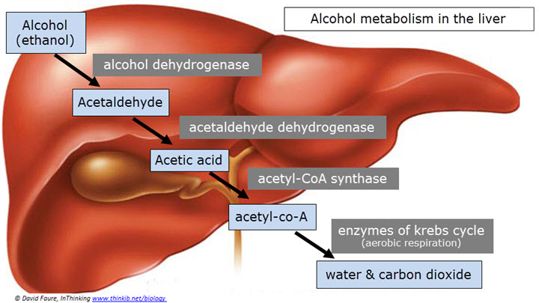
Yth etyh

Questions
- Which enzyme has the product acetaldehyde?

……………………………………………………………………………………………………

- Which enzyme has the substrate acetaldehyde?

……………………………………………………………………………………………………

- How do the enzymes link together to form a metabolic pathway?

…………………………………………………………………………………………………….….………………………………………………………………………………………………….….…….…………………………………………………………………………………………………

Enzymes and Activation Energy
Enzymes catalyse very many reactions in all living organisms. After watching the animation answer the questions:

Watch the following summary animation about how enzymes function to lower the activation energy. Follow this up by watching the video:
- Animation – How enzymes work
- Video – Enzymes activation energy

This diagram summarises some of the main points.
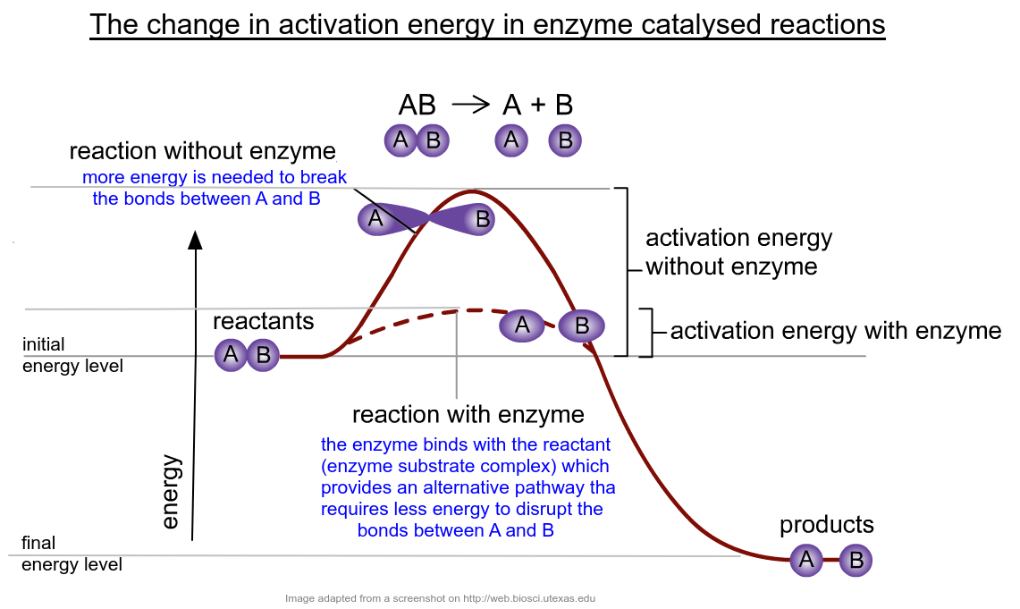

Enzymes catalyse chemical reactions. (Topic 2.5) We know that they have an active site where the substrate binds and that when a substrate collides with an active site then a reaction occurs. The reason that enzymes speed up these reactions is all to do with the reaction’s activation energy.
Activation energy = the minimum amount of energy required to start a chemical reaction.
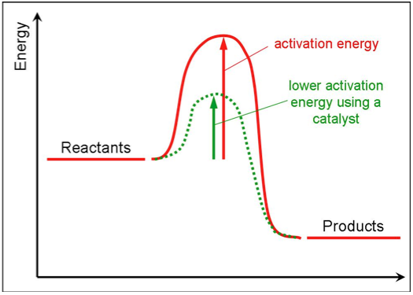
- Use this Animation – Activation energy and enzymes

- Name a specific biological example of the reaction in the diagram above? Write a word equation of the reaction (If you are struggling think ‘digestion’)
…………………………………………………………………………………………………….….………………………………………………………………………………………………….…..…….…………………………………………………………………………………………………
- Describe what happens at the peak of the graph shown above.
…………………………………………………………………………………………………….….………………………………………………………………………………………………….….…….…………………………………………………………………………………………………
- Explain what an enzyme does to the activation energy and why it speeds up the reaction?
…………………………………………………………………………………………………….….………………………………………………………………………………………………….….…….…………………………………………………………………………………………………

