Transcription & Translation

For each example:
- fill in the complimentary DNA strand
- fill in the correct mRNA bases by transcribing the bottom DNA code
- fill in the correct tRNA bases
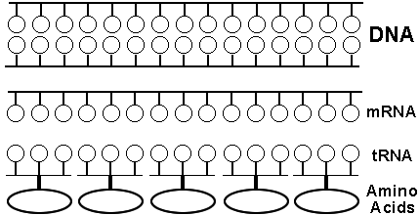
- translate the mRNA codons to find the correct amino acids
A T G G T A G C T A A C C T T
Example #1

Example #2
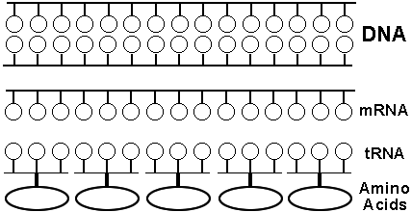
C A G G A A T T G C T C G A T
.

Example #3

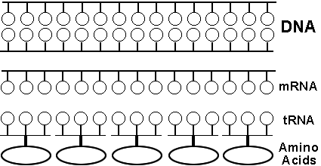
G T A C T C A A G G T C T A G

Example #4
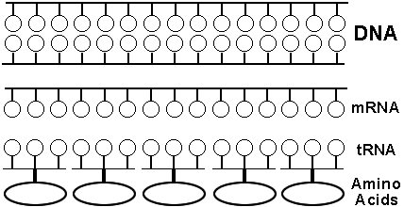
T T T C A A T C G A C C A A C

