Protein Synthesis & Amino Acid Worksheet

DNA | DNA & RNA | RNA | Protein Synthesis
deoxyribonucleic acid | base | ribonucleic acid | amino acid
deoxyribose | nucleotide | ribose | codon
hydrogen bond | pentose sugar | messenger RNA | anticodon
thymine | phosphate | transfer RNA | transcription
 | backbone | mRNA | translation
 | rungs | tRNA | polypeptide
 | cytosine | ribosome | protein
 | guanine
 | adenine
Label the Diagrams:
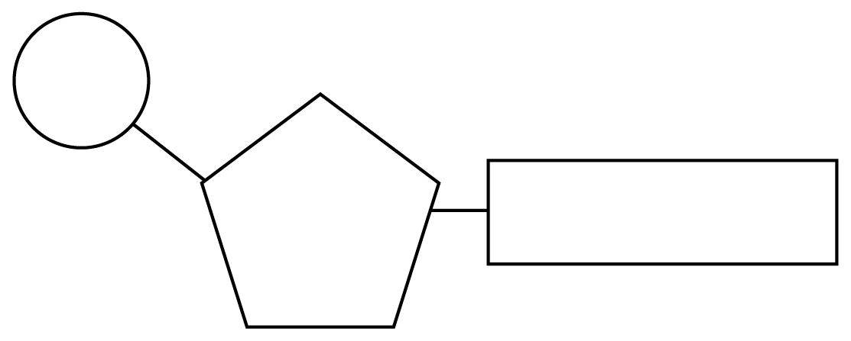
Follow the colouring scheme for each diagram below, then label the parts listed.
Nucleotide Structure
phosphate group – brown five-carbon sugar – orange nitrogen(ous) base – purple

DNA Structure
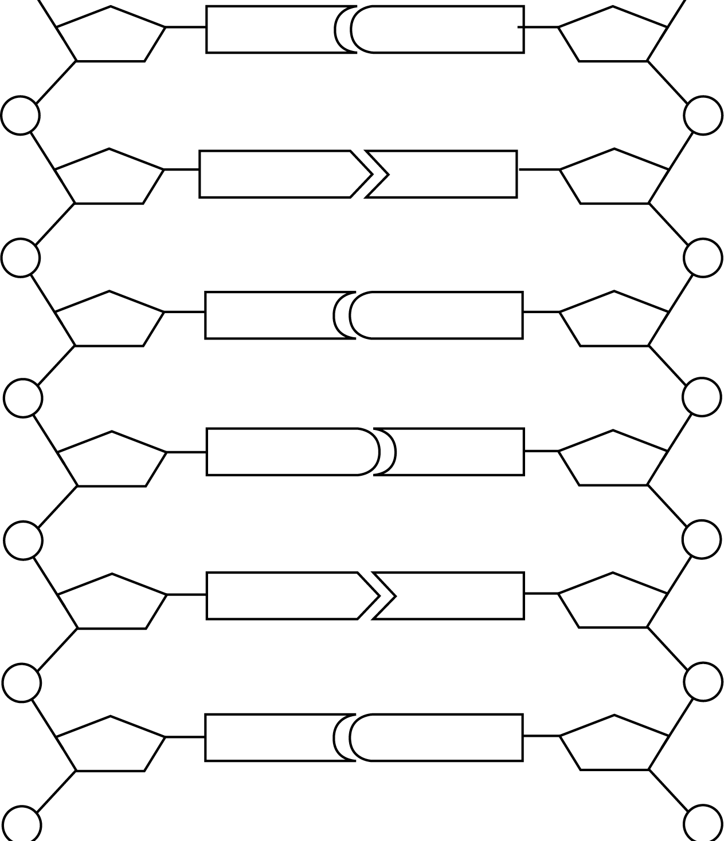
sugar-phosphate backbone – brown/orange adenine – red
thymine – green cytosine – blue
guanine – yellow
hydrogen bond – black

- Fill in the complimentary DNA strand using DNA base pairing rules.
- Fill in the correct mRNA bases by transcribing the bottom DNA code.
- Translate the mRNA codons and find the correct amino acid using the Codon Circular Table.
- Write in the amino acid and the correct ant-codon, the tRNA molecule.
- Then answer the questions about protein synthesis below the amino acids.

Original  DNA | Complementary  DNA | Codon  mRNA | Anti-Codon  tRNA | Amino Acid
A | T | A | U | Met., Methionine  The start codon
T | A | U | A
G | C | G | C
G
T
A
G
C
T
A
A
C
C
T
T

mRNA
Here’s another way to look at the same process. Fill in all the circles and ovals.

Original Strand
C
A G G A
A
T
T
G C
T
C G A
T
DNA

- Where is mRNA synthesized, transcription or translation?
Amino Acids
tRNA

- Does mRNA have codons or anti-codons?

- How many codons equal one amino acid, 1 or 3?

- Does tRNA bring amino acid to the nucleus or ribosomes?

- Is a polypeptide a sequence of proteins or amino acids?

- Does tRNA have codons or anti-codons?

- Does tRNA transfer amino acids during transcription or translation?

- Are ribosomes the site where translations or transcription takes place?

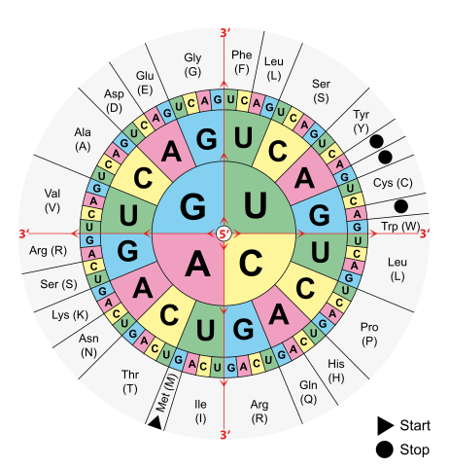
Codon to Amino Acid Circular Chart
Start at center of chart with the 5´end. Then work out from center toward 3´end to find amino acid abbreviation.

Amino Acid | Three Letter | Single Letter |  | Amino Acid | Three Letter | Single Letter
Alanine | ala | A |  | Leucine | leu | L
Arginine | arg | R |  | Lysine | lys | K
Asparagine | asn | N |  | Methionine | met | M
Aspartic Acid | asp | D |  | Phenylalanine | phe | F
Cysteine | cys | C |  | Proline | pro | P
Glutamic Acid | glu | E |  | Serine | ser | S
Glutamine | gln | Q |  | Threonine | thr | T
Glycine | gly | G |  | Tryptophan | trp | W
Histidine | his | H |  | Tyrosine | tyr | Y
Isoleucine | ile | I |  | Valine | Val | V

List of Amino Acids

