2.1.U1 Molecular biology explains living processes in terms of the chemical substances involved. 2.1.U4 Metabolism is the web of all the enzyme-catalysed reactions in a cell or organism.

- The structure of DNA was discovered in 1953, since then molecular Biology has transformed our understanding of living processes.
  - Outline the relationship between genes (DNA) and polypeptides.

  - Outline what the term metabolic pathway means.

  - Referring to the term metabolic pathway describe what the term metabolism means to a molecular biologist.

  - Describe the reductionist approach that a molecular biologist uses discover the working of a metabolic pathway.

  - Explain why ultimately the reductionist approach used by molecular biologists might be a limited one.

2.1.U2 Carbon atoms can form four covalent bonds allowing a diversity of stable compounds to exist.

- Despite only being the 15th most abundant element on the planet carbon forms the backbone of every single organic molecule.
  - What type of bonds can carbon molecules form? And how does the strength of these bonds compare with other types of bond?

  - Explain why Carbon can form four bonds with up to four different atoms, and explain why.
2.1.U3 Life is based on carbon compounds including carbohydrates, lipids, proteins and nucleic acids.

- Compare the key feature of the different groups of organic molecules by completing the table below.

 | Key features | Examples
carbohydrates
lipids
proteins
nucleic acids

2.1.S1 Drawing molecular diagrams of glucose, ribose, a saturated fatty acid and a generalized amino acid.

- Draw the simplified (ring) structures of glucose and ribose. Number the carbon atoms correctly. Which sugar is a pentose? Which is a hexose? How are they named this way?

- Octanoic acid is a fatty acid with the formula CH₃(CH₂)₆COOH. Draw the structure of molecule and explain why it is called a saturated fatty acid.

- Draw the generalised structure of an amino acid. Label and annotate the diagram to show the different groups that comprise amino acids.

2.1.S2 Identification of biochemicals such as sugars, lipids or amino acids from molecular diagrams.

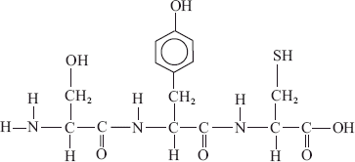
- Which type of molecule is shown in the diagram to the right?

- The diagrams below show various molecular structures.

  - Identify which of the diagrams represent:
    - the structure of glucose.
I.

III.

CH₃

O

(CH ₂) _{n} C

OH

CH ₂OH
II.

IV.

HOH₂ C

C H
O

C
H
H H OH
C C

OH OH

R

    - the structure of an amino H O

acid.

    - the structure of fatty acids.
C
H
H
C OH

OH C H
O H

H C

C OH OH

N C C

H OH
H

  - Discuss which of the molecules are most similar in structure.

2.1.U5 Anabolism is the synthesis of complex molecules from simpler molecules including the formation of macromolecules from monomers by condensation reactions.
2.1.U6 Catabolism is the breakdown of complex molecules into simpler molecules including the hydrolysis of macromolecules into monomers.

- Distinguish between the terms anabolism and catabolism.

 | anabolism | catabolism
synthesis or
breakdown?
type of reaction
substrates
products
water produced or
used?
enzymes/agent
involved

- Annotate the diagram below to complete your notes on anabolism and catabolism. In the carbohydrate section add a named example, include both the names of the molecules and enzymes.
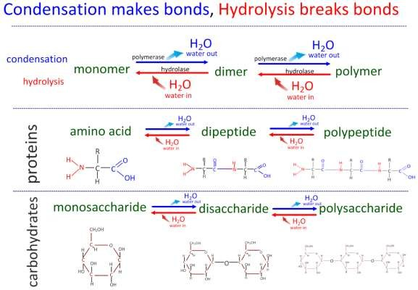

2.1.A1 Urea as an example of a compound that is produced by living organisms but can also be artificially synthesized.

- Vitalism is a theory that nowadays has no credit.
  - Describe the central tenant that Wöhler falsified.

  - Wöhler accidentally artificially synthesised urea, hence falsifiying vitalism. What compound was he trying to produce?

  - Accidental discoveries are a surprisingly common part of the development of scientific understanding. Referring to the IB guide identify which ‘Nature of Science’ points this example applies to.

