Pattern Matching: Organic Molecules PART 1

What are living things made of? Sugar and spice and all things nice? (Or snips and snails and puppy dog tails . . .) Common sense tells us that living things are somehow different from non-living things, but how deep does that difference run? Are living things made from different kinds of atoms than those in non-living things? Different kinds of molecules?

There may be as many as 10,000 different kinds of molecules in a living thing. But are there a few common patterns? A few common functions?

Objectives:
- Know what an organic molecule is and how it differs from an inorganic molecule.
- Identify the major classes of organic molecules.
- Identify the distinguishing features of each class of molecules.
- Given a typical example of an organic molecule, identify the class to which it belongs.

Pattern Matching
Table 1 reviews the most common atoms found in living organisms and some of their properties. (These atoms also occur in non-living things.) As you work, notice if the atoms in your molecules follow the indicated bonding patterns.

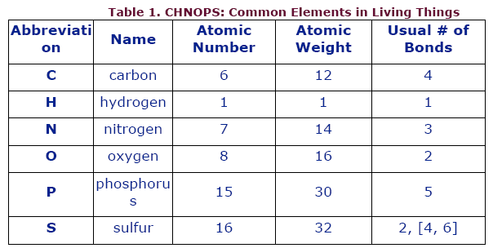

Identifying Categories of Biological Molecules
The objects you will be sorting are basic building blocks (subunits) of common macromolecules in living things. Do NOT refer to your books during this exercise. Use your own judgment in doing the sorting.

Cut out the set of unlabeled molecules. Organize the 42 cards into groups based upon structural similarities. Pay special attention to:
- the elements (CHNOPS) in the molecule,
- the shape of the molecule,
- patterns within the molecule, and
- the ends of the molecule.

In your blue book, in complete sentences:
How many groups of molecules do you have? Explain your reasoning for creating these particular groups. (Quick-and dirty sketches of general molecule shapes can be part of your explanations.)

Pattern Matching: Organic Molecules PART 2

Chemists and other scientists use a variety of representational styles or conventions for drawing molecules, and they shift easily between them. We’ll learn about and practice using different styles for depicting molecules:

- Molecular formula: a molecular formula simply counts the numbers of each sort of atom present in the molecule, but tells you nothing about the way they are joined together. For example, the molecular formula of butane is C₄H₁₀, and the molecular formula of ethanol is C₂H₆O. Molecular formulae are very rarely used in organic chemistry, because they don't give any useful information about the bonding in the molecule.

- Full displayed formula: A displayed formula shows all the bonds in the molecule as individual lines. You need to remember that each line represents a pair of shared electrons. For example, ethane (C₂H₆) would be shown as:
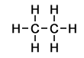

Remember, each carbon atom can form 4 bonds and each hydrogen atom can form one bond. In the full displayed formula, every atom and every bond is shown.

- Skeletal formula: in organic chemistry, skeletal formulae are the most abbreviated diagrammatic descriptions of molecules. They look very bare because in skeletal formulae the hydrogen atoms (attached directly to carbons) are removed, leaving just a "carbon skeleton" with functional groups attached to it. Don't be fooled: The hydrogen atoms are present in the molecules but their presence is assumed - rather than drawn or stated.

In skeletal formulas, the carbons are known to exist at the end of a line or at the “kink” in a chain. For example, pentane (C₅H₁₂) would be:

Atoms other than carbon and hydrogen ARE shown in skeletal formula.

OK! Let’s start learning about some specific molecules!

GROUP 1: Amino Acids - Building Blocks of Proteins
Amino acids are the building blocks of proteins - molecules that play many important roles in the body (including muscle structure, hormones, antibodies, hemoglobin for carrying oxygen, other transport proteins for carrying molecules across cell membranes, toxins, and chemical messengers in the nervous system).

The figure below shows three ways of depicting the same “generic" amino acid.

Molecular formula: | Full displayed formula: | Skeletal formula:
C₂H₄O₂NR  The molecular formula is not helpful and we won’t use it | 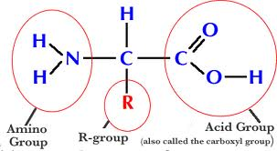 | O  OH  R  H₂N

In your blue book:
Draw and title the full display and skeletal figures shown above. Circle and label the amine group, carboxyl group and side chain group on your drawings of the generalized amino acid.

If we connect multiple amino acids together into a chain, the resulting structure is called a “polypeptide.” The amino acids connect through a condensation reaction.

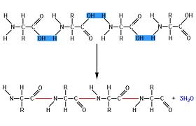
The "-N-C-C-" in the center of the molecule is known as its “backbone” and is a defining feature of polypeptides.

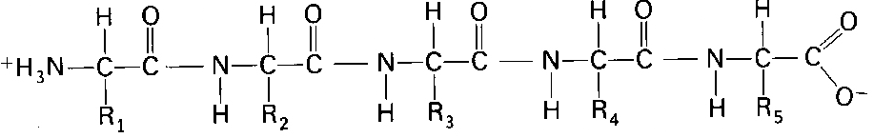

In your blue book:
Redraw the chain of amino acids linked in a chain as shown above. Title your drawing. Highlight the atoms of the backbone. Put a box around each individual amino acid (hint: there are 5).

Each amino acid has a different side group that is represented by "R" in the generalized structure. The “R” group is what makes each type of amino acid different from the other amino acid molecules.

In your blue book:
Find and paste the 14 amino acids in your set of molecules into your lab book. Be sure they are collectively titled as “Example Amino Acids.” Highlight the atoms of the backbone in one colour and the atoms of the “R” group in a different colour.

Pattern Matching: Organic Molecules PART 3

GROUP 2: Steroids – A Type of Lipid
Cholesterol, shown below, is a steroid. Steroids are one type of molecule in the class of compounds known as lipids. Cholesterol plays an important role in membrane formation.
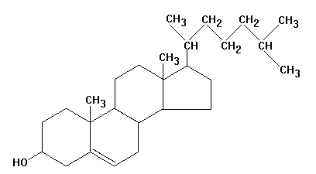

Steroids can be recognized by their multiple rings of carbon atoms connected together. “But wait,” you say, “I don’t see any carbon atoms in the four rings in the cholesterol molecule!” Remember, organic chemists use many shortcuts in drawing complex molecules. The structure shown above is a mix of a skeletal formula and a full display formula.

Because organic molecules include so many carbon atoms, chemists often do not include the letter C for carbon. In the cholesterol molecule above, there is a carbon atom (not drawn in most cases) at every point of each of the four rings and in the side chain. The bonds between the carbons are shown. In all but one case the carbon atoms are connected to one another by a single bond (one pair of shared electrons). In one ring there are two carbon atoms connected by a double bond (which means they are sharing two electrons).

To further simplify this drawing, many of the hydrogen atoms have not been drawn. However, since each carbon atom forms four bonds, it is assumed that the bonds not depicted are to hydrogen atoms.

In your blue book:
Find and paste the 3 steroids in your set of molecules into your lab book. Be sure they are collectively titled as “Example Steroid Molecules; A Type of Lipid.” Underneath or next to each molecule, please draw the molecule, representing all carbon atoms as “C”’s and including the missing hydrogen atoms bonded to the carbons. Remember, every carbon atom will form 4 bonds with other atoms.

Pattern Matching: Organic Molecules PART 4

GROUP 3: Fatty Acids – Another Type of Lipid
You should have some long hydrocarbon chains with a carboxyl group at one end. One of the defining features of these hydrocarbon chains is the absence of oxygen except in one carboxyl group at one end of the molecule. These hydrocarbon chains are fatty acids. Fatty acids are the building blocks of oils and fats. There are two fatty acids in each of the millions of phospholipids that make up your cell membranes; saturated and unsaturated.

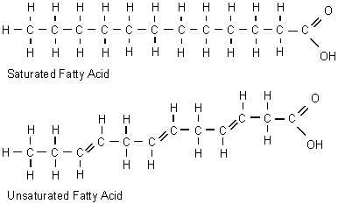

In your blue book, in complete sentences:
Describe the difference between a saturated fatty acid and an unsaturated fatty acid.

In your blue book:
Find and paste the 3 fatty acids in your set of molecules into your lab book. Be sure they are collectively titled as “Example Fatty Acids; A Type of Lipid.” Label each fatty acid as either saturated or unsaturated. Highlight and label the carboxyl group on each of the fatty acids.

Pattern Matching: Organic Molecules PART 5

GROUP 4: Sugars - Building Blocks of Carbohydrates
Sugars are the building blocks of carbohydrates. They are literally hydrates of carbon, having the general formula "C_{n}(H₂O)_{n}". Sugars are burned (oxidized) to release energy in cellular respiration and they play an important role in homeostasis. Your body maintains the level of the sugar glucose in your blood within a very narrow range. Glucose is the immediate source of energy for your cells.

Sugars occur as ring structures. There are monosaccharides (single rings), disaccharides (double rings), and larger. In solution, single rings can dynamically change from straight chains to rings and back to straight chains. The same sugar molecule shown in ring and straight chain form is show below.

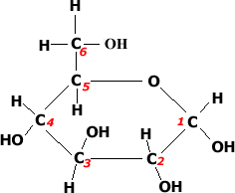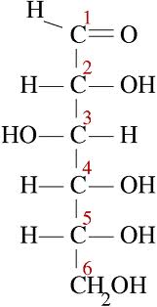

In your blue book:
What is the molecular formula for the sugar shown above? Explain how the sugar fits the generalized sugar formula of C_{n}(H₂O)_{n}.

In your blue book:
Find and paste your 6 straight chain sugars in your book. Title the molecules as straight chain monosaccharides. Determine the molecular formula for each of the straight chain sugars. Then, explain why the molecular formula alone is not distinct enough to distinguish these different sugars from each other.

Do you see how the carbons are numbered in the pictures shown above on this page? The carbon number is going to be important for us to identify when we start talking about DNA structure and function. Here’s how you determine the numbers of the carbon atoms in a ring shaped monosaccharide:
  - Find the oxygen in the ring
  - Move clock wise from the oxygen
  - Number the carbons in the order that they appear

In your blue book:
Find and paste your 2 ring shaped monosaccharide sugars in your book. Title the molecules as ring shaped monosaccharides. Determine the molecular formula for each of the sugars. Then, number the carbons in the molecule.

Sugars can be joined together in chains. Two connected sugar molecules are together called a disaccharide.
In your blue book:
Find and paste your 2 disaccharide sugars in your book. Title the molecules disaccharides.

Pattern Matching: Organic Molecules PART 6

GROUP 5: Nucleic Acids -- Single and Double Ring Molecules Containing Nitrogen
So far we have identified three of the four major classes of molecules in living things:
- Proteins and their subunits amino acids,
- Lipids including fats and oils with their subunits, fatty acids, and steroids,
- Carbohydrates, including starch, cellulose, and glycogen with their subunits, sugars.

You probably recognize these three types of molecules as major food groups as well as major classes of biological molecules. In contrast, nucleic acids, the fourth and last major group of molecules, are not a major food group.

Nucleic acids include two kinds of molecules, RNA (ribonucleic acid) and DNA (deoxyribonucleic acid), and their subunits. In most organisms, DNA contains the genetic blueprint for the organism and is reproduced in its entirety in every cell of its body. RNA helps to translate the information in DNA into the production of thousands of different kinds of proteins, which in turn control development of the organism.

A unique characteristic of the nucleic acids is the presence of a “nitrogenous base”. The nitrogenous bases consist of single or double rings. Each ring contains two nitrogen atoms. DNA contains four nitrogenous bases: adenine (A) and guanine (G), each with double rings, and cytosine (C), and thymine (T), with single rings. RNA contains three of these, A, G, and C, and a fourth base, uracil (U).

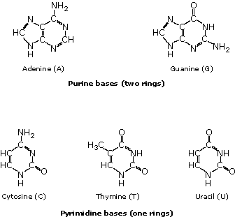

In your blue book:
Find and paste all five of the nitrogenous bases into your lab book. Label appropriately with the name of the molecule and indicate whether it is a purine or pyrimidine.

A nitrogenous base can combine with a five-carbon sugar, either ribose (for RNA) or deoxyribose (for DNA), as shown below.

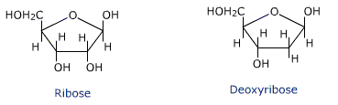
In your blue book:
Draw and title the figure shown above. Highlight the difference between the molecules. Draw in and number the carbon atoms that are not shown above.

Molecules that contain both a nitrogenous base and a five carbon sugar are called nucleosides. For example:

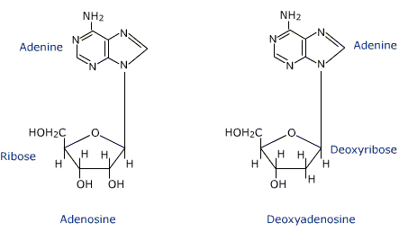

In your blue book:
Find and paste the 4 nucleoside molecules. Label appropriately. Additionally, label the sugar of each as either ribose or deoxyribose.

Nucleosides can combine with one, two or three phosphates to form a nucleotide. The greater the number of phosphates, the greater the energy contained in the molecule. Adenine triphosphate (ATP) is not only a major subunit of DNA and RNA, but also is a major energy carrier in living systems. You can it has a base (adenine), a sugar (ribose) and three phosphate groups.

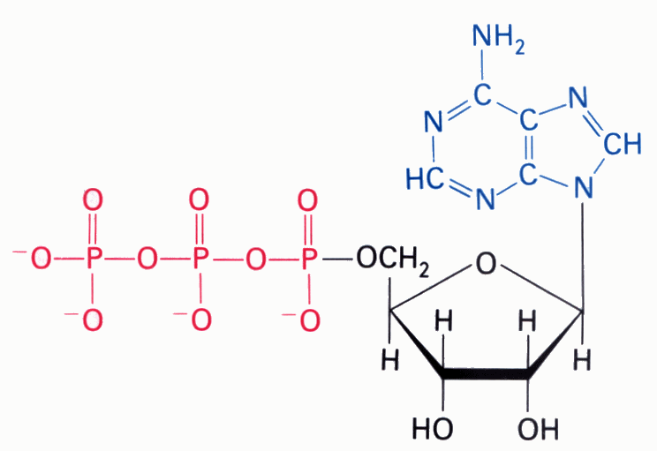
BASE
SUGAR
PHOSPHATES

In your blue book:
Find and paste three nucleotides. Label appropriately. Additionally, label the sugar of each as either ribose or deoxyribose.

Pattern Matching: Organic Molecules PART 7

Summary
Organic molecules are carbon-based, whereas inorganic molecules are not. Each class of macromolecules is built up from subunits. Except for cellulose, they are easily assembled and disassembled.

There are four major classes of organic molecules:
- Proteins - the workhorses (enzymes, hormones, carriers, etc.) of the cells
- Lipids - energy storage & protection, hormones, cholesterol , and phospholipids (membrane structure)
- Carbohydrates - energy carriers, structural units
- Nucleic acids - genetic information and ATP

In your blue book:
Create a data table to record:
- The 4 classes of organic molecules
- Named examples of each of the 4 classes of organic molecules
- A distinguishing structural feature of each class of organic molecule

In your blue book, in complete sentences:
Go back to your initial predictions of molecule groupings (the very first thing you did in this activity). For EACH of your initial groups, indicate to which of the 4 classes of organic molecules the group belongs. You can either do this at the end of the work OR next to your initial groupings at the beginning of the lab.

In your blue book, in complete sentences:
List 5 things you learned by completing this activity. For example:

I learned…

