Nomogram
This nomogram can be used to calculate BMI - join your height to your weight with a line and read the resulting BMI:
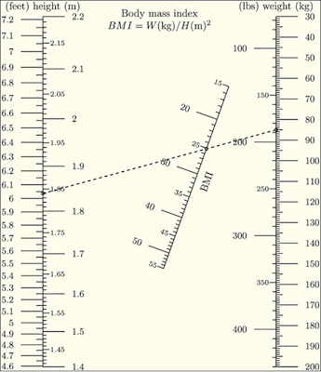

Questions:
- After calculating using the online BMI, scroll down the results page of the Wolfram calculator to see what your BMI value means. Describe the conclusion you can make from your BMI?

- Compare your BMI to the BMI values of other people.

- Which of the methods of calculating BMI values is the most precise? Try to explain why.

