Carbohydrates and Lipids

2.3.U1 Monosaccharide monomers are linked together by condensation reactions to form disaccharides and polysaccharide polymers.

- Condensation of monosaccharides is a polymerization reaction. It can continue to create a longer chain of saccharides (a carbohydrate). These building reactions are part of the anabolic metabolism.
  - Define polymer.

  - Monosaccharides are quickly and absorbed and readily used in cell respiration to release energy List the three key examples of 6-carbon monosaccharides.

  - Annotate and complete diagram below to outline how two monosaccharides are converted into a disaccharide through condensation, producing a glycosidic bond. Include a word equation.
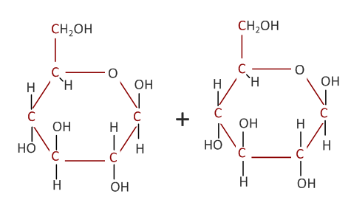

  - What else is needed to make the reaction occur?

- Complete the table to summarise the common forms of disaccharides.

Disaccharide | Produced by plants or animals? | Produced from which Monosaccharides? | Commonly found in
 | plant
Lactose | animal |  | milk
 |  | glucose + fructose | sugar beet and sugar cane

2.3.A1 Structure and function of cellulose and starch in plants and glycogen in humans.

- All three common polysaccharides are formed by the condensation of glucose molecules. Their properties however are markedly different complete the table to summarise how and why.
 | Polysaccharide
 | Cellulose | Starch |  | Glycogen
 |  | Amylose | Amylopectin
Size / number of glucose molecules | variable, typically 1,500 units
Orientation and / or bonding of glucose molecules | 1-4 bonds between alternately oriented (upwards and downwards) glucose molecules
chain - straight or bent? |  |  |  | bent
chain - branched or un-branched? |  |  |  | branched
Properties of the molecule |  | - Insoluble, does not affect the osmotic balance of cells  - Molecule vary in size , easy to add / remove glucose units
Function/use |  | - Useful for glucose, and consequently energy, storage, e.g. in seeds and storage organs such as potato cells.  - Temporary store in leaf cells when glucose is being made faster by photosynthesis than it can be exported.

2.3.S1 Use of molecular visualization software to compare cellulose, starch and glycogen.

- The easiest way to use jmol is to use the ready-made models from on the Biotopics website (http://www.biotopics.co.uk/jsmol/glucose.html#). Play with the models, move them and zoom in and out.
  - Select the the glucose molecule and identify the colours used to represent carbon, hydrogen and oxygen atoms

Carbon –
Hydrogen –
Oxygen –

  - Using the models identify and describe the differences between glucose, sucrose and fructose (hint: descriptions will be clearest if you refer to the numbered carbon atoms, see 2.3.U1)

  - Look at the amylose model and zoom out from it. Describe the overall shape of the molecule.

  - Zoom in on the amylose molecule. Each glucose sub-unit is bonded to how many other sub-units? Which carbons atoms used to form the glycosidic bonds? Are there any exceptions to these rules?

  - Select the amylopectin model and zoom in on the branch point. This glucose sub-unit is bonded how many others and which carbon atoms are used for bonded compared with the un-branched amylose molecule?

  - Using a similar approach to that above investigate the structure of glycogen and find the similarities and differences between it and both amylose and amylopectin.

2.3.U2 Fatty acids can be saturated, monounsaturated or polyunsaturated.

- Fatty acids in the production of lipids.
  - In the space below, draw the generalized structure of a fatty acid.

  - Describe the term saturated when used in reference to fatty acids.

  - For each of the following fatty acids deduce whether it is saturated, monounsaturated or polyunsaturated, Give reasons for each answer.
    - Oleic Acid

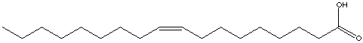

    - Caproic Acid

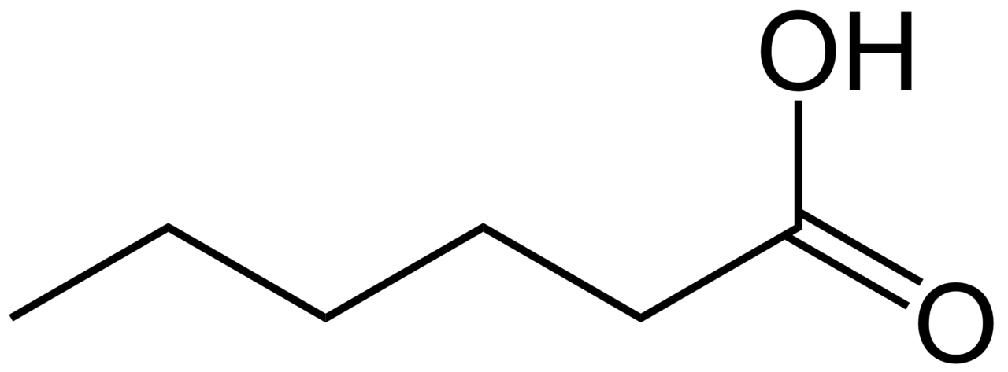

    - α-Linolenic Acid

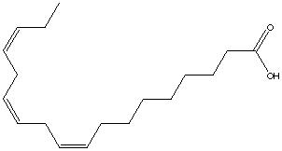

2.3.U3 Unsaturated fatty acids can be cis or trans isomers.

- Unsaturated fatty acids are described as being cis or trans isomers depending on the structure of the double bonds in the fatty acids.
  - Complete the table to compare and contrast cis and trans isomers.

 | Cis-isomers | Trans-isomers
Structural diagram | 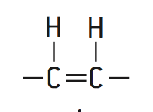 | 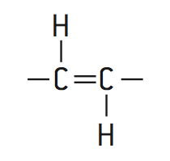
Natural / synthesised | Very common in nature | Rare in nature – usually artificially produced to produce solid fats, e.g. margarine from vegetable oils.
Positioning of the hydrogen atoms
Shape of the fatty acid chain | The double bond causes a bend in the fatty acid chain
Packing of the fatty acids (density) |  | Trans-isomers can be closely packed
Triglyderides formed are liquid or solid at room temperature?

- Identify which isomer is cis and which is trans. Give reasons for your decisions.

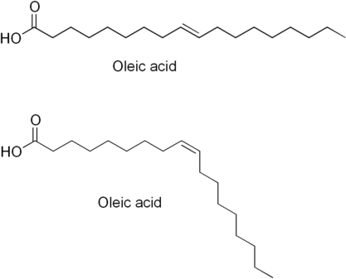
______ - https://www.wisc-online.com/learn/natural-science/life-science/ap13104/biomolecules-the-carbohydrates -
______ - https://www.wisc-online.com/learn/natural-science/life-science/ap13104/biomolecules-the-carbohydrates -

2.3.A4 Evaluation of evidence and the methods used to obtain the evidence for health claims made about lipids.

- What does the term evaluation mean?

- Describe the key considerations for strengths.

- Describe the key considerations for limitations

- Read the analysis on the article on “Health Warning: Exercise Makes You Fat” published on Bad Science (http://www.badscience.net/2009/08/health-warning-exercise-makes-you-fat/).
  - Is the health claim a valid one?

  - Review the analysis and identify which key considerations of strengths and limitations were addressed.

2.3.A2 Scientific evidence for health risks of trans fats and saturated fatty acids.

- There have been many claims about the effects of different types of fat on human health. The main concern is coronary heart disease (CHD).

  - Outline Identify the causes and effects of CHD.

  - Discuss the evidence that CHD is caused by a diet high in trans fats and saturated fatty acids.

2.3.U4 Triglycerides are formed by condensation from three fatty acids and one glycerol.

- Triglycerides are a common type of lipid formed from three fatty acids and one glycerol.
  - Draw the generalized structure of a glycerol molecule

  - Annotate and complete diagram below to outline how three fatty acids and one glycerol molecule are converted into a triglyceride through condensation, producing ester bonds. Include a word equation.

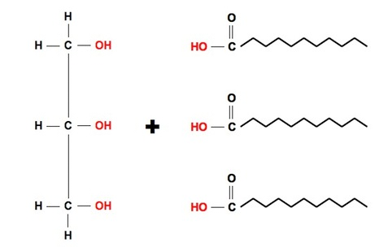

image adapted from: http://www.ib.bioninja.com.au/standard-level/topic-3-chemicals-of-life/32-carbohydrates-lipids-and.html

2.3.A3 Lipids are more suitable for long-term energy storage in humans than carbohydrates.

- Lipids are normally used for long-term energy storage whereas carbohydrates are used for short-term energy storage.
  - When the energy in carbohydrates is released what is produced?

  - The chemical energy stored in the form of glucose is for immediate use in what process?

  - Glycogen is the medium-term energy storage molecule in animals.
    - Where is it stored?

    - Why is it used in preference to lipids?

  - The lipids used in energy storage are fats. Where and how are they stored in humans and other mammals?

  - Explain the advantages that lipids have over carbohydrates in long-term energy storage:

2.3.S2 Determination of body mass index by calculation or use of a nomogram.

Body Mass Index (BMI) is used as a screening tool to identify possible weight problems, however, BMI is not a diagnostic tool. To determine if excess weight is a health risk further assessments are needed such as:
- skinfold thickness measurements
- evaluations of diet
- physical activity
- and family history

BMI is calculated the same way for both adults and children. The calculation is based on the following formula:
BMI = mass in kilograms
(height in metres)²

n.b. units for BMI are kg m⁻²

BMI | Status
Below 18.5 | Underweight
18.5 – 24.9 | Normal
25.0 – 29.9 | Overweight
30.0 and Above | Obese

The BMI status of someone can be assessed using the table to the right.

- A man has a mass of 75 kg and a height of 1.45 metres.
  - Calculate his body mass. (1)

  - Deduce the body mass status of this man using the table. (1)

  - Outline the relationship between height and BMI for a fixed body mass. (1)

- A woman has a height of 150 cm and a BMI of 40.
  - Calculate the minimum amount of body mass she must lose to reach normal body mass status. Show all of your working. (3)

  - Suggest two ways in which the woman could reduce her body mass. (2)

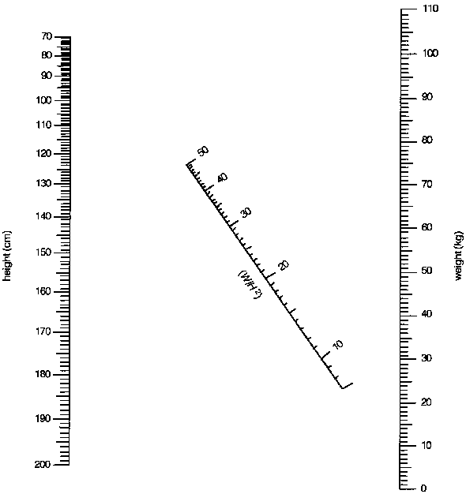
- Use the nomogram to answer the following questions.
  - A women has a mas of 75 Kg and a height of 160cm. Determine her BMI status.

  - A man is 190cm tall and has an acceptable BMI. Estimate his body mass.

http://helid.digicollection.org/documents/h0211e/p434.gif

