Biochemical molecules

When drawing molecular diagrams which show all the atoms which make up a molecule and the way in which they are bonded together it is first important to know how many bonds each molecule has.
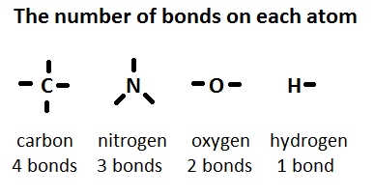

When drawing the biological molecules checking that each atom has the right number of bonds, will avoid mistakes.
A good way to remember the structures is to draw each diagram in three steps

- Draw the ring of carbon atoms (C)
- Add the oxygen (O) or the hydroxide (OH) - and nitrogen in an amino acid (N)
- Fill in all the remaining bonds with hydrogen (H) using the number of bonds above.

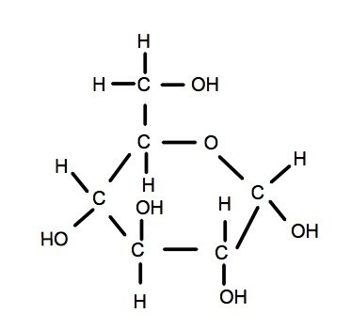
Drawing α-glucose (alpha-glucose)

Hints:

- Draw the hexagon using 5Cs and 1O
- Add the 6th C above the 5th C
- Draw the -OH groups in their correct positions
(this is the difference between alpha and beta glucose)
- It is correct to draw -OH or HO- ( but not OH- or -HO.)
- Add H2OH to the 6th C
- Add -H to all the carbons to make 4 bonds per carbon

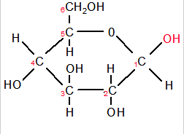
Drawing β-glucose (beta-glucose)

Hints:

- Make a note of the similarities between beta-glucose and alpha-glucose
- Beta glucose has all the same parts as its alpha glucose isomer
- Simply take care to draw the -OH groups in their correct positions (for beta glucose the OH on the 1st C must be at the top)

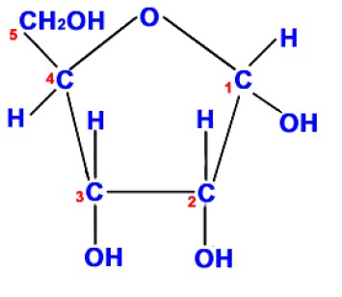
Drawing ribose

Hints:

- Ribose is similar to glucose in several ways:
  - carbons 1, 2 & 3 all have an H and an OH attached.
  - the last carbon(5) is also CH2OH.
- Ribose only has 5 carbon atoms
- Draw a pentagon using 4 Cs and with an O at the top
- Add a 5th carbon above the 4th C.
- Add H2OH to the 5th carbon
- Add 3 OH groups beneath Carbons 1, 2 & 3.
- Add a H to all the carbon atoms with fewer than 4 bonds.

Drawing a saturated fatty acid

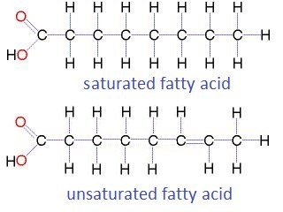

Hints:

- Draw 8 carbon atoms in a chain
- Add the carboxyl group =O and -OH to the first carbon
- Add hydrogen atoms to all the carbons to make 4 bonds per carbon atom – this is saturated
- Note the last carbon needs three H atoms.

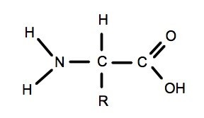
Drawing an amino acid

Hints:

- This molecule is similar to a fatty acid because of the carboxyl group (C=O & -OH)
- Remember N has just 3 bonds
- The R group represents the part of the molecule which is different in each amino acid.

Reading Activity: How was vitalism disproved by the synthesis of urea?

Use the following links and make notes to explain how the synthesis of urea helped to disprove the theory of vitalism - the idea that there is a 'vital force' in living organisms as well as in organic molecules.
Web links:

- http://youtu.be/YNmfSHSq_HY
- http://humantouchofchemistry.com/urea-and-the-beginnings-of-organic-chemistry.htm

