Enzyme Activity Worksheet

Part 1: Temperature and Enzyme Activity

Use the graph below to answer questions 1-3.

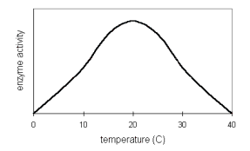

- At what temperature does this enzyme work the fastest?

- Why does enzyme activity increase on the left side of the graph?

- Why does enzyme activity decrease on the right side of the graph?

- Humans share several enzymes with thermophilic bacteria. What does the graph below suggest about the conditions under which these thermophiles live?
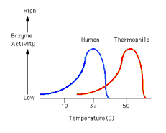

Part 2: pH and Enzyme Activity

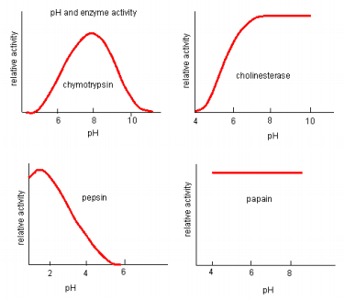
Based on the graph above:

- Which enzyme works best in neutral conditions?

- Which enzyme is not affected by pH?

- Which enzyme works under alkaline conditions?

- Which enzyme might be found in acidic gastric juices?

