DNA Structure
- Label the structures of this single nucleotide.
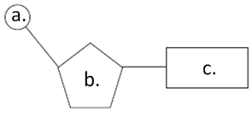 | a.
 | b.
 | c.

- Complete the table below to show the pairings of the bases in DNA:

Purine | Pyramidine

- Where is the base uracil found?

- In the space below, draw a single strand of three nucleotides, naming the bonds between them and showing the correct relative position of these bonds.

- In the space below, draw a section of DNA, showing two anti-parallel strands of three nucleotides. Label the bonds which hold the bases together as well as the correct complementary base pairs. Include also: 5’-3’ ends and linkages.

- Define the term double helix.

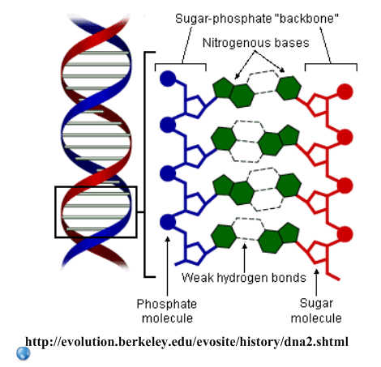
- Explain the relevance of the following in the double-helix structure of DNA:
- Complementary base pairing

- Hydrogen bonds

- Relative positioning of the sugar-phosphate backbone and the bases

- The discovery of the structure of DNA earned a Nobel Prize for Watson, Crick and Wilson.
Go to the Nobel Prize website: http://nobelprize.org/educational_games/medicine/dna_double_helix/readmore.html

Discuss how this is a good example of the following:

- Internationalism in science?

- Cooperation in science?

- Competition in science?

