Experiment: The need for digestion and enzymes

Introduction
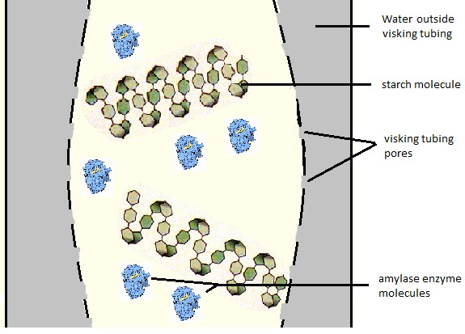
We are going to make a model gut using Visking tubing as a model of digestion and absorption of nutrient molecules across the intestine wall. Visking tubing is a partially permeable membrane, it has small pores.

Visking tubing has small pores and makes a good model of the small intestines. Starch molecules and enzymes molecules are too large to pass through the pores in the visking tubing, just like the endothelium of the intestines.

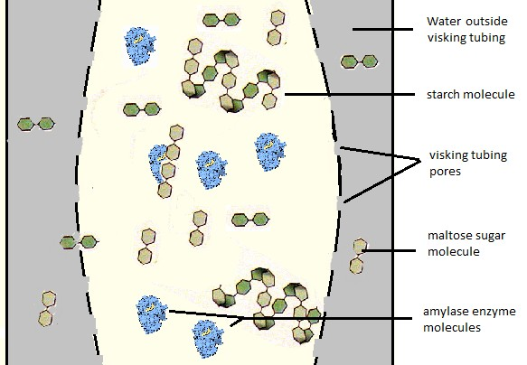
Enzymes catalyse the hydrolysis of large starch molecules into smaller sugar molecules. In the case of amylase it hydrolyses the starch into maltose. A disaccharide.

Equipment (per group)
- Benedict’s solution
- Two 15cm lengths of Visking tubing
- four pipettes
- saliva (5% solution of amylase)
- 1% starch solution (5 ml)
- spotting tile
- two boiling tubes
- two elastic bands
- two syringes (10 ml)

Method
- Take the 15cm lengths of Visking tubing and tie a knot in one end wetting it and twisting it to do so.
- Using a syringe, carefully add 5ml of 1% starch solution into both pieces of tubing.
- Using a clean syringe, add 3ml of amylase solution into one piece of visking tubing.

- Holding the top of the tubing, wash the outside of it under a tap (to clean off any starch that may have been spilt).
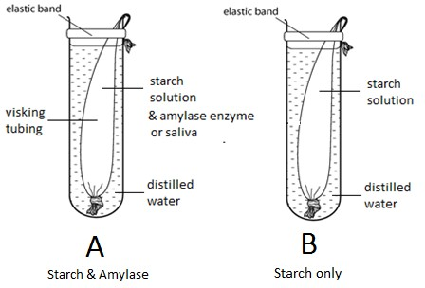
- Place the tubing inside a boiling tube fold the top of the visking tubing over the rim of the boiling tube and place an elastic band around the top of the tube. This is to hold the top end of the tubing in place.
- Add distilled water to the boiling tubes up to the level shown in the diagram.
- Put the tubes in a water bath at 37°C for 20 minutes to allow diffusion & hydrolysis.

Analysing the results Testing for starch
- Use a pipette to take small volume of the liquid from the water outside the tubing
- Put two drop of it into one of the wells in the spotting tile.
- Carefully unfasten the elastic band and open up the top of the tubing.
- Use a clean pipette to take a few drops of the liquid inside the tubing.
- Put two drop of this solution into a second well in the spotting tile.
- Add a drop of iodine solution to each liquid.
- A blue / black coloured precipitate shows that starch is present.
- Record what happens.

Testing for maltose sugar
- Take half a pipette (1ml) each of the liquids from inside and outside the Visking tubing using two clean pipettes.
- Put each liquid sample into a separate labelled test tube.
- Add 10 drops of Benedict’s solution to each tube.
- Put the test tubes into a water bath at 90°C (or into a beaker of boiling water)
- Wait for up to 5 minutes for a colour change. An orange / red colour shows the presence of a reducing sugar, e.g. Maltose
- Record your results.

Answer the following questions (during the 20 minutes diffusion time)

- Look at any diagram of the digestive system. What do each of the following things represent in your visking tubing model of the small intestine?
  - the Visking tubing
.................................................................................................

  - the liquid inside the tubing solution

.................................................................................................

  - the water outside the tubing

................................................................................................. (3)

- Where is amylase secreted in the human body

......................................................................................................................................

..................................................................................................................................... (2)

- What is the difference between a ‘macro-molecule’ and a ‘monomer’

......................................................................................................................................

..................................................................................................................................... (1)

- What are Villi, what do they do and where are they found in the small intestines?

.....................................................................................................................................

......................................................................................................................................

.....................................................................................................................................

......................................................................................................................................

..................................................................................................................................... (2)

Results
 | Tube A (starch & amylase) |  | Tube B (starch only)
 | Inside visking tubing | Outside Visking tubing | Inside visking tubing | Outside Visking tubing
Results of the Starch test with iodine
Results of the Reducing sugar (maltose) test with Benedicts reagent

- Explain the results or your experiments.

....................................................................................................................................

.....................................................................................................................................

.....................................................................................................................................

..................................................................................................................................... (2)

- Why do we need to digest our food?

......................................................................................................................................

..................................................................................................................................... (1)

- Why do we need to digest our food?

......................................................................................................................................

..................................................................................................................................... (1)

