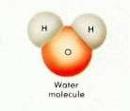
Biological importance of Water
Observation Lab

It has been said that “the chemistry of life is water chemistry.” Because of its chemical properties, water is the medium in which most of life’s chemical
- Please, no more than three people per lab station at any given time.
- You may rotate through the stations in any order.
- Please clean up after yourself at each station.
reactions occur. Life first evolved in water, it resided there exclusively for three billion years, most life is now concentrated in water-rich areas, and the cells of organisms are about 70 to 90 percent water.

Because of its polarity, water molecules attract to each other forming hydrogen bonds. This attraction of like molecules is called cohesion. Because water is cohesive, it remains liquid at normal temperatures over much of the Earth.
Cohesion allows water to move up through plants and it results in the tension that allows some organisms to live on the surface of water. Water’s polarity results in many important characteristics, such as adhesion, high heat capacity, and its versatility as a solvent.

You will be assigned to a group of 3. You will rotate through the lab stations and perform the activities outlined below. For each activity, use your phone to take a photo or video of your group illustrating the activity described.

Once you are done with the hands-on activities, compile your photos/videos into a single presentation. Use an app to add AUDIO voiceover to explain the science behind the water activity at each station. Your team can work together to write a script to explain each activity but each member of your group must be heard at least three times on the completed presentation. When you explain the science, be sure you include the key ideas included in the table below.

This assignment will count as a formative assessment.
Due Thursday (project submission details will be outlined at a later time)

You MUST clean up after yourself at each station.

STATION | ACTIVITY | EXPLAIN USING…
1A | Using the model kits, determine the maximum number of H-bonds that a water can form with other waters.  Tidy the station, but no specific clean up required | Polar  Hydrogen bonding Cohesion
1B | Make staples float on water. Challenge… make a paperclip float on water (without bending the clip).  Empty and refill the beaker of water.  DO NOT allow staples or paper clips down the drain. | Polar  Hydrogen bonding Cohesion  Surface tension
2A | Count the number of drops of water you can put on top of a 5 Baht coin. Compare to the number of drops of oil you can put on top of the 5 Baht coin. Use the sponge (and spray cleaner for the oil) to wipe down the station. | Polarity  Hydrogen bonding Cohesion

STATION | ACTIVITY | EXPLAIN USING…
2B | Fill a beaker with water and sprinkle a pinch of pepper on the top. Touch the tip of a toothpick into some liquid soap. Then, place the soapy tip into the water with pepper. Observe what happens.  Pour the water and pepper down the drain. Return the toothpick to the beaker with the liquid soap. | Polar  Hydrogen bonding Cohesion  Surface tension Hydrophobic
3A | Use molecular model kits to show what water looks like as a solid, a liquid and a gas.  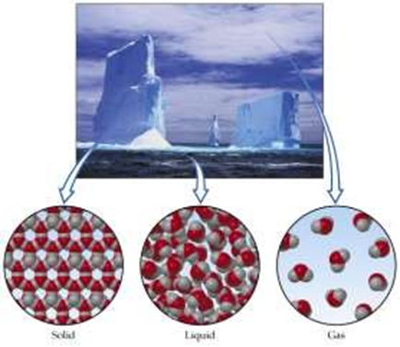  Tidy the station, but no specific clean up required | Polar  Hydrogen bonding Density
3B | Determine if ice sinks or floats when placed in liquid water.  Tidy the station, but no specific clean up required | Polar  Hydrogen bonding Density
4A | Wet a piece of string and tie it to a graduated cylinder. Position one end of the string over the spout and put the other end into an empty cup. Pull the string taught. Slowly pour the water along the string so it moves from the graduated cylinder into the cup.  Use a sponge to wipe down the lab station | Polar  Hydrogen bonding Cohesion Adhesion
4B | Observe a stalk of celery in a beaker of coloured water.  Tidy the station, but no specific clean up required | Polar  Hydrogen bonding Cohesion Adhesion
5A | Use the molecular model kits view the simulation of the adhesion of water to a tube.  Please do not move the models on the tube.  Tidy the station, but no specific clean up required | Polar  Hydrogen bonding Cohesion Adhesion
5B | Make water move against gravity up a capillary tube. Tilt the capillary tube at about a 45-degree angle from a drop of water on the lab station.  Use a sponge to wipe down the lab station | Polar  Hydrogen bonding Cohesion Adhesion
6A | Add a small pinch of salt (an ionic compound) in a test tube. Fill the tube with water and cap. Shake to mix the contents. What happens to the salt crystals? Pour the salt and water. Rinse out the test tube. | Polar  Hydrogen bonds Ion  Solvent Hydrophilic
6B | Use molecular model kits to explain how water dissolves salt (an ionic compound)  Tidy the station, but no specific clean up required | Polar  Hydrogen bonds Ion  Solvent Hydrophilic
7A | What will happen if water comes in contact with a nonpolar molecule? Mix oil and water to find out.  Tidy the station, but no specific clean up required | Polar Nonpolar Hydrophobic
7B | Observe the temperature of boiling water. Is it changing?  CAUTION: HOT!!!  Tidy the station, but no specific clean up required | Polar  Hydrogen bonds Cohesion  Heat capacity
8A | Drop 1 drop of water on the lab station and one drop of ethanol on the lab station. Rub the drops around with a finger to spread out the liquids then compare the time it takes each to evaporate.  Use a sponge to wipe down the lab station | Polar  Hydrogen bonds Cohesion  Heat capacity
8B | Read a sentence through a glass of water  Tidy the station, but no specific clean up required | Transparency

