Water

2.2.U1 Water molecules are polar and hydrogen bonds form between them.

- Draw a minimum of three molecules to show the hydrogen bonding between them. The diagram should be labelled and annotated to indicate:
- Large oxygen atom
- Small hydrogen atom
- Covalent bond
- Due to the greater +ve charge of the oxygen nuclei the shared electrons reside closer to the oxygen nuclei. This leads to the imbalance of charges in the molecule as a whole.
- δ+ (indicate the region of each molecule which possesses a slightly positive charge )
- δ- (indicate the region of each molecule which possesses a slightly negative charge)
- The imbalance of charges in a water molecule results in water being a polar molecule
- Weak hydrogen bond between δ+ and δ- parts of neighbouring water molecules.

- Explain why the water molecule is polar. Refer to electrons and covalent bonding in your answer.

2.2.U2 Hydrogen bonding and dipolarity explain the cohesive, adhesive, thermal and solvent properties of water.

- Summarise the key points on each property of water and how it relates to the structure of the water molecule. Also give examples of the importance it has to organisms. Each example should use one or more of the following phrases/terms: coolant, medium for metabolic reactions and transport medium.

 | Outline the property | Explain how the property is due to either hydrogen bonding or dipolarity | Give examples of how organisms exploit this property
Cohesive

Adhesive

Thermal

Solvent

2.2.U3 Substances can be hydrophilic or hydrophobic.

- Define the terms:
  - Hydrophilic

  - Hydrophobic

- Complete the table to give examples of hydrophilic and hydrophobic molecules.

 | Polar, non-polar, charged? | Examples
Hydrophilic
Hydrophobic

2.2.A3 Modes of transport of glucose, amino acids, cholesterol, fats, oxygen and sodium chloride in blood in relation to their solubility in water.

- Complete the table to describe the transport of key substances in the blood.
 | Describe the solubility in water | Relate how it is carried in the blood to the solubility
glucose
amino acids
cholesterol
fats
oxygen
sodium chloride
2.2.A2 Use of water as a coolant in sweat.

- Outline the consequences to cells, of not cooling the human body.

- What property of water means it is useful as a coolant?

- Explain how the body exploits this property of water to cool the body using sweat.

2.2.A1 Comparison of the thermal properties of water with those of methane.

- Complete the table to compare the thermal properties of water with methane.
 | Methane | Water
 | 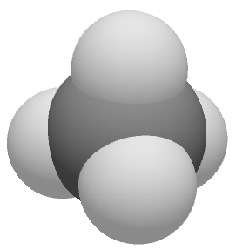 | 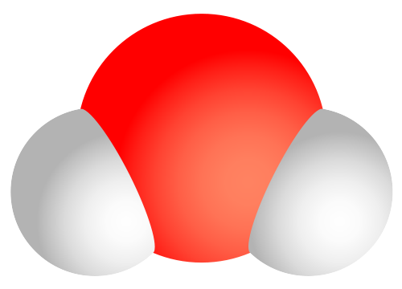
Formula |  | H₂O
Molecular mass | 16
Bonding | Single covalent
Polarity |  | polar
Density (g cm⁻³) | 0.46
Specific Heat Capacity (J g⁻¹ ºc⁻¹) | 2.2
Latent heat of vapourisation (J g⁻¹)
Melting point (ºC) |  | 0
Boiling point (ºC) |  | 100
- Referring to the table above, outline how the polarity of water has affected the thermal properties and its ability to remain a liquid at most temperatures found on the surface of the planet.

