2.5.U1 Enzymes have an active site to which specific substrates bind.

- Define the following terms:
  - Enzyme

  - Active site

  - Substrate

  - Product

- Describe three examples of enzymes giving the substrates and products.

Enzyme | Substrate | Product

- What suffix is commonly applied to enzymes?

- Explain enzyme-substrate specificity, using a diagram and referring to the lock-and-key model.

- State the function of polar regions of amino acids on the active site of the enzyme.

- Describe the induced-fit model of enzyme activity, with reference to the lock and key theory, conformational change and activation energy.

2.5.U2 Enzyme catalysis involves molecular motion and the collision of substrates with the active site.

- State what is meant by the term collision in enzyme catalysis.

- Explain why not all collisions between enzymes and substrates result in catalysis.

- Explain why the presence of water is critical for most enzyme reactions.

- Enzymes can be immobilized (e.g. embedded in cell membranes). Enzymes can also be free to move, but they tend to move more slowly than substrates, explain why.

2.5.U4 Enzymes can be denatured.

- With the use of annotated diagrams explain how the denaturing of an enzyme affects its ability to catalyse reactions.

2.5.U3 Temperature, pH and substrate concentration affect the rate of activity of enzymes.

- Explain the effects of temperature, pH and substrate concentration on the rate of an enzyme-controlled reaction.

Temperature
pH
Substrate concentration

2.5.U5 Immobilized enzymes are widely used in industry.

- List eight common uses of enzymes in industry.

- Enzymes used in industry are commonly immobilised.
  - Describe the advantages of immobilising enzymes.

  - List three ways in which enzymes can be immobilised.

2.5.A1 Methods of production of lactose-free milk and its advantages.

- Although all children produce lactase some adults are lactose intolerant, they lose the ability to produce lactase in adulthood.

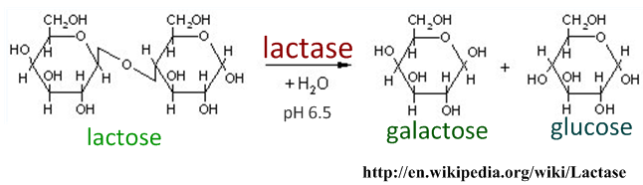
  - State the three other commercial reasons that lactose free milk is produced.

  - Outline the process by which lactose-free milk is produced by immobilised enzymes.

2.5.S1 Design of experiments to test the effect of temperature, pH and substrate concentration on the activity of enzymes.

- Design an experiment to test the effect of either temperature, pH or substrate concentration on the activity of an enzyme. Your design should:
- Be written up in the form of sentences and paragraphs, not numbered steps
- Specify the enzyme and/or organism you are working with
- State the independent variable, state the values used and describe how it will be changed
- State the dependent variable and detail how it will be measured, the units and equipment used. Additionally if calculations are to be performed on the dependent variable they need to be outlined.
- List the control variables and outline how they will be controlled.
- A reliable experiment needs either a large sample or repeated measurements.

