Lactose Intolerance
Enzymes are proteins that speed up chemical reactions. Lactose is a disaccharide (carbohydrate) that is found in milk. In the digestive system of most babies, it is broken down into the monosaccharaides glucose and galactose. The enzyme lactase is released in the intestine to speed up this digestion.
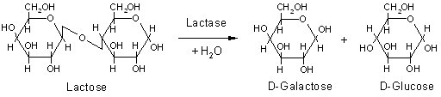
In some adult humans, levels of lactase are too low to digest lactose in milk adequately. Instead, lactose passes through the small intestine into the large intestine, where bacteria feed on it, producing carbon dioxide, hydrogen and methane. These gases cause some unpleasant symptoms, discouraging consumption of milk. The condition is known as lactose intolerance. It has sometimes in the past been regarded as an abnormal condition, or even as a disease, but it could be argued that lactose intolerance is the normal human condition.
The first argument for this view is a biological one. Female mammals produce milk to feed their young offspring. When a young mammal is weaned, solid foods replace milk and lactase secretion declines. Humans who continue to consume milk into adulthood are therefore unusual. Inability to consume milk because of lactose intolerance should not therefore be regarded as abnormal.
The second argument is a simple mathematical one: a high proportion of humans are lactose intolerant (see Figure below).
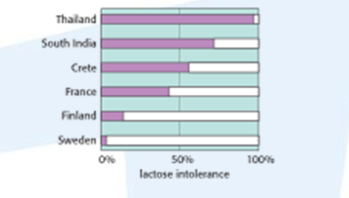
The third argument is evolutionary. Our ancestors were almost certainly all lactose intolerant, so this is the natural or normal state. Lactose tolerance appears to have evolved separately in at least three centres: Northern Europe, parts of Arabia, the Sahara and eastern Sudan, and parts of East Africa inhabited by the Tutsi and Maasai peoples. Elsewhere, tolerance is probably due to migration from these centres.

Questions:
- Compare the structures of lactose with the structure of glucose.

2. i) Determine the percentage of the population of Thailand that is deemed to be lactose intolerant.

ii) Identify the country with the lowest level of lactose intolerance shown in the graph.

3. Explain why lactose tolerance has been thought of as normal, rather than lactose intolerance.

4. Lactase is widely used in food processing.
a) Choose one of the following food products and conduct research so that you can explain the role of lactase in the process of creating the product:
- flavoured milk products such as fruit yoghurt
- ice cream
- syrup

The command term ‘explain’ requires a summary of reasons and mechanisms; in other words, the ‘how’ and the ‘why’ of the process.

b) Evaluate the use of lactase in the particular process you have chosen. An evaluation requires you to assess the implications and limitations of the process.

Rubric
1. Compare the structures of lactose with the structure of glucose.
Lactose is a disaccharide and glucose is a monosaccharide/ glucose is simpler than lactose;
Glucose is a component of lactose;
Glucose has an OH group where lactose contains an O between two molecules;
2. i) Determine the percentage of the population of Thailand that is deemed to be lactose intolerant.
95%

ii) Identify the country with the lowest level of lactose intolerance shown in the graph.

Sweden

3. Explain why lactose tolerance has been thought of as normal, rather than lactose intolerance.
Tolerance is more common in Europe/people of European descent;
View that tolerance is normal would come from European global hegemony;
Dairy products are inexpensive / widely produced / global production and marketing leads people to consume dairy products when they normally wouldn’t;
4. Answers dependent on student research.

