Transcription and Gene Expression

- Give example(s) of genes that are transcribed in all cells, because their proteins are essential in all cells.

…………………………………………………………………………………………………………………………….

…………………………………………………………………………………………………………………………….

- What are transcription factors?

…………………………………………………………………………………………………………………………….

…………………………………………………………………………………………………………………………….

- Where, exactly, does transcription occur in the cell?

…………………………………………………………………………………………………………………………….

…………………………………………………………………………………………………………………………….

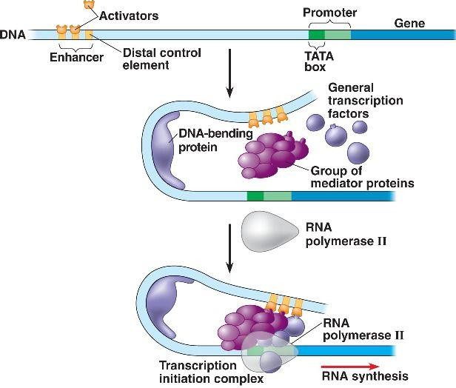
The transcription protein complex is made up of a group of proteins attached to DNA.
Image: CC BY 2.0 from SUNY Oswego's Cellular Physiology Wiki

- What do these proteins do?

…………………………………………………………………………………………………………………………….

…………………………………………………………………………………………………………………………….

